**USER MANUAL “GYM ZONE”**



**INDEX**

**1. Introduction 3**

**2. Main screens 4**

2.1. Role Selection 4

2.2. Home 5

2.3. Log In 6

2.4. Register 8

2.5. User Profile 11

2.6. Bank Account Management 12

**3. Monitor functions 15**

3.1. Create Routine 16

3.2. Routine Management 17

**4. Nutritionist functions 19**

4.1. Create Diet 20

4.2. Diet Management 21

**5. Administrator functions 23**

5.1. Routine Management 24

5.2. Room Management 24

5.3. Product Management 26

5.4. Service Management 29

**6. Customer functions 31**

6.1. Customer Data Query 32

6.2. Payments Products and Services 33

6.3. Reservation Management 38

6.4. Routine Consultation 45

6.5. Diet Consultation 47

# **Introduction**

This document has been designed to help you understand and use all the functionalities of our gym management system. Here, you will find a detailed guide on how to navigate and take full advantage of the various screens and features available on the platform.

The “Gym Zone” system is created to meet the needs of different types of users, including Clients, Nutritionists, Monitors and Administrators. Each role has access to a number of specific functionalities that allow them to manage their activities and responsibilities efficiently.

This manual will explain how to use the desktop application for each screen of the system, organized according to the functionalities corresponding to each type of role.

# **Main screens**

Next, we will detail the main screens that make up the application that will be used by all types of users, providing clear and precise instructions on how to use each of them to take full advantage of all the features offered by the application.

## **Role Selection**

This screen will appear, when the application starts, where we will have to choose the desired role.

We can choose the following available roles:

* Customer: this type of role can use the functionalities to make use of the gym.
* Nutritionist: this type of role can manage diets.
* Monitor: this type of role can manage routines.
* Administrator: this type of role can manage all the main functions of the gym.

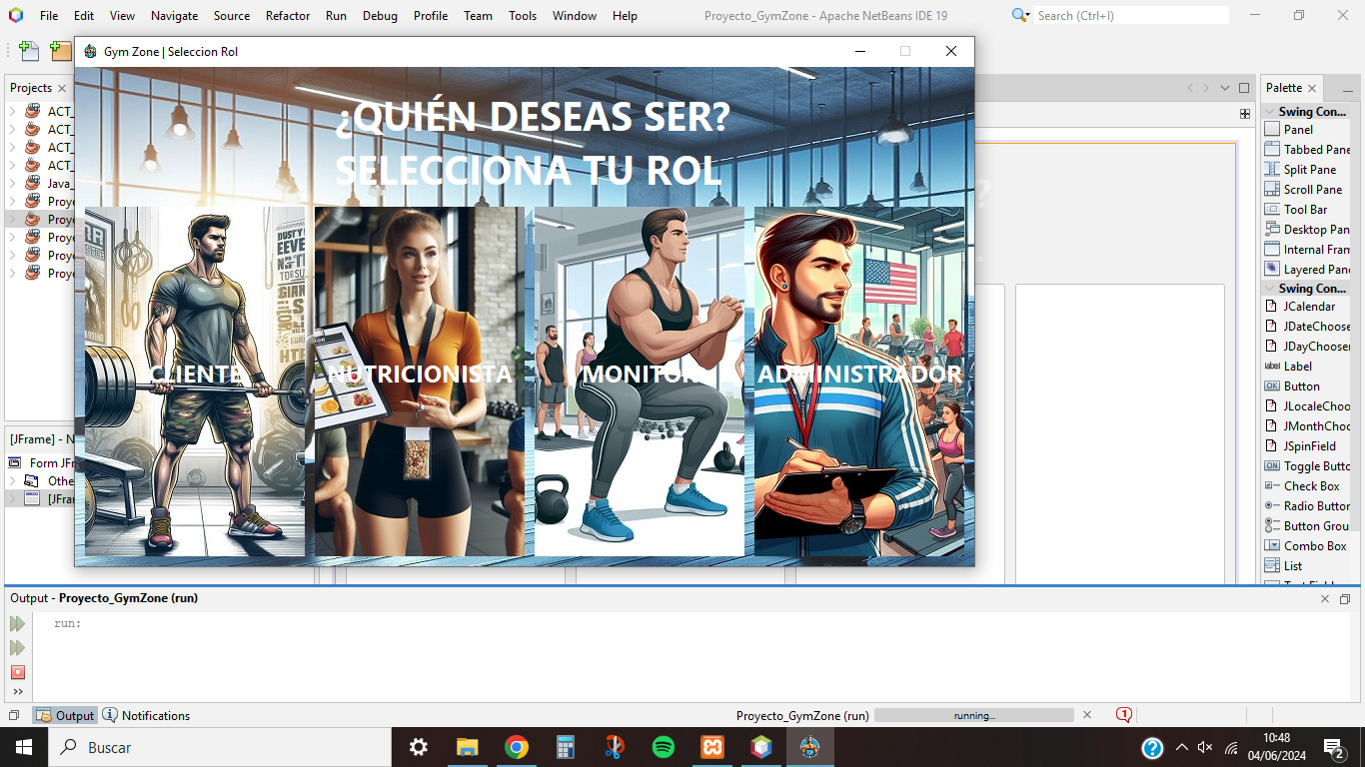

## **Home**

This screen allows all users to go to the login or register screen or even go back to the role selection screen.

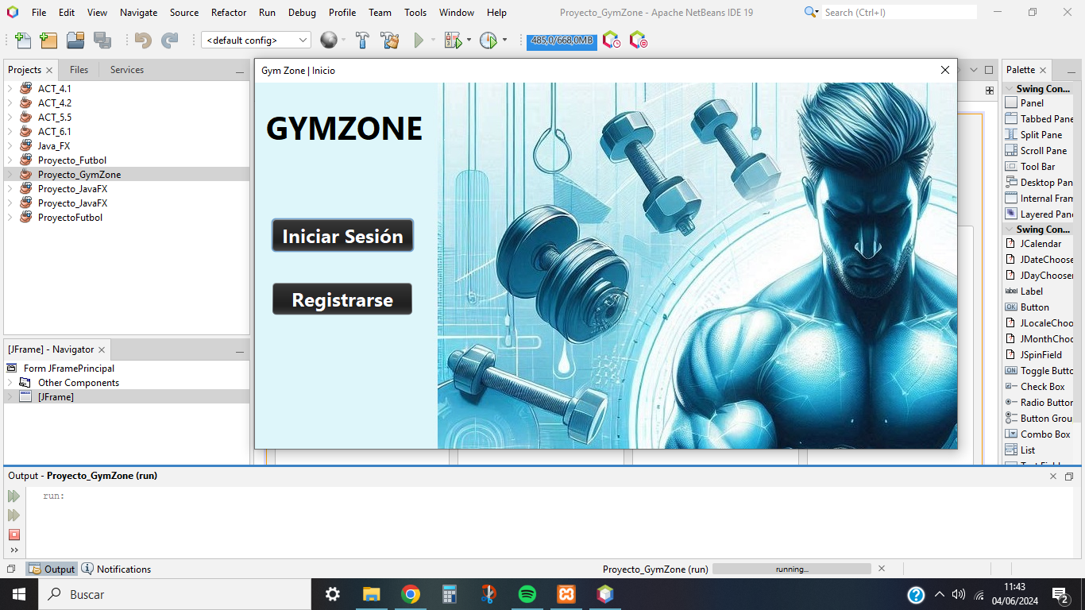

## **Log In**

This section allows you to log in for all the selected roles where you will have to enter the ID or your email or the user name and the corresponding password.

Also, you can go back to the home page or go to the registration screen if you do not have an account registered in the system.

The user will be checked according to the chosen role, for example, if you have chosen the customer role, when you log in with your respective data, the system will check the data stored in the database.

If the data is correct, the users enter their corresponding main window with their respective functionalities that they can perform according to their assigned role.

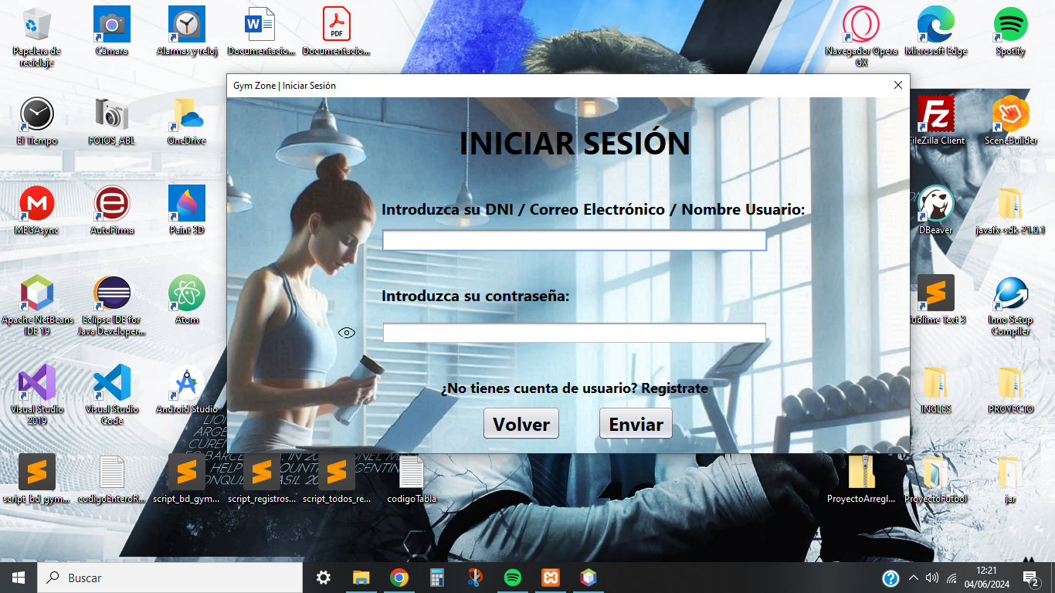

In the event that the data is entered incorrectly or does not match your personal data (ID, email, user name) with the password, the application will warn the user about it.

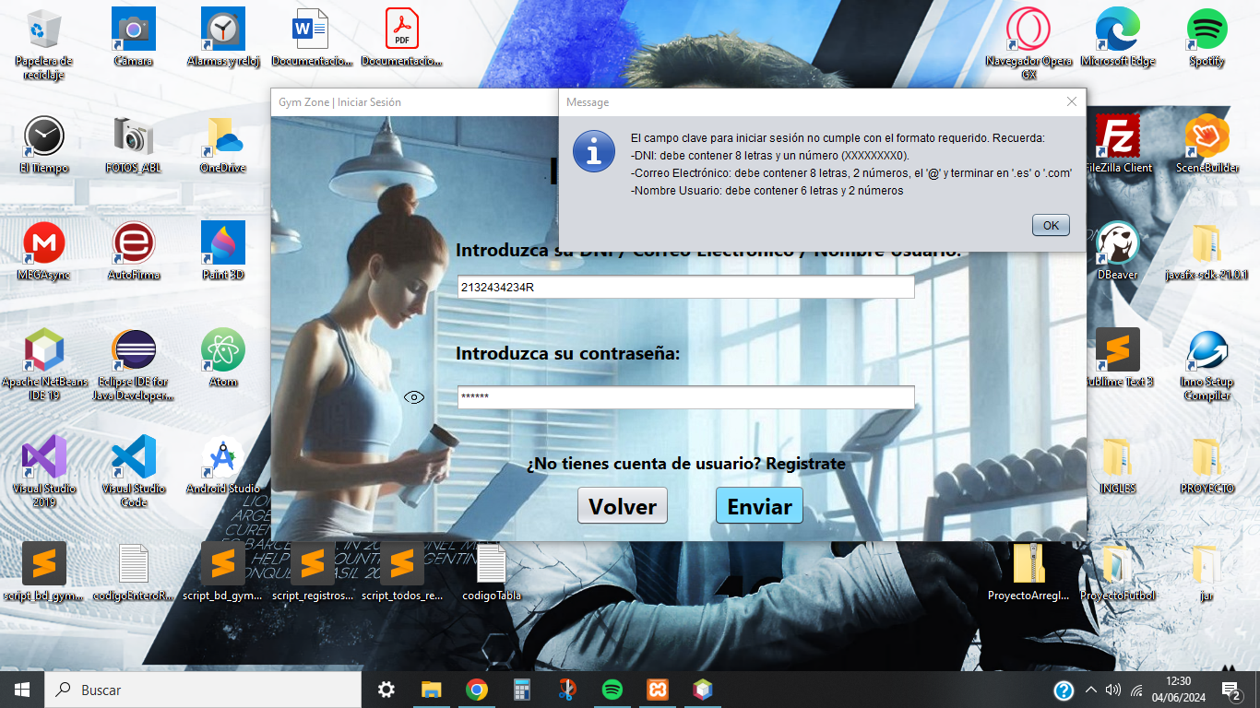

## **Register**

This screen allows you to register all users regardless of their role, where you will subsequently have to register their unique data pertaining to the specific role that has been chosen, expected for the administrator as it is an Administrator type monitor. Also, like the previous screen it gives the possibility to go to home or go to the login screen if the user has a registered account.

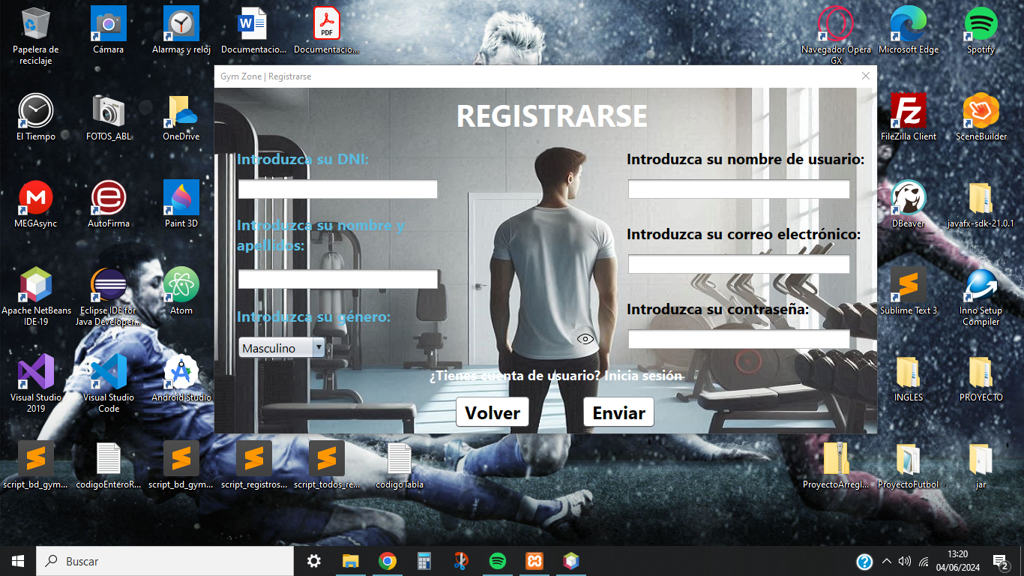

As in the previous screen and the rest of the screens where you will have to fill in the corresponding data, the data that must be entered correctly will be validated, otherwise the user will be informed.

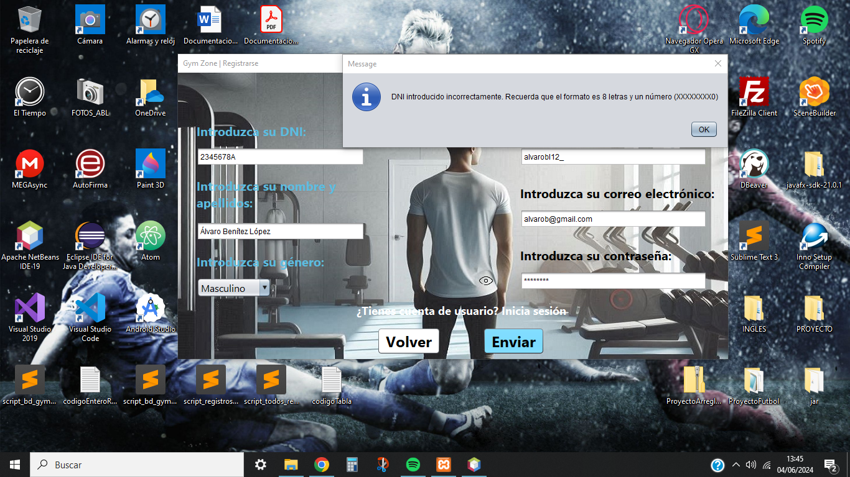

Depending on the selected role, it will show another form when the form with general data to be filled in is completed, where it will ask for specific data.These are the screens:

* Customer registration: displays a form where the customer fills in his personal and body data.

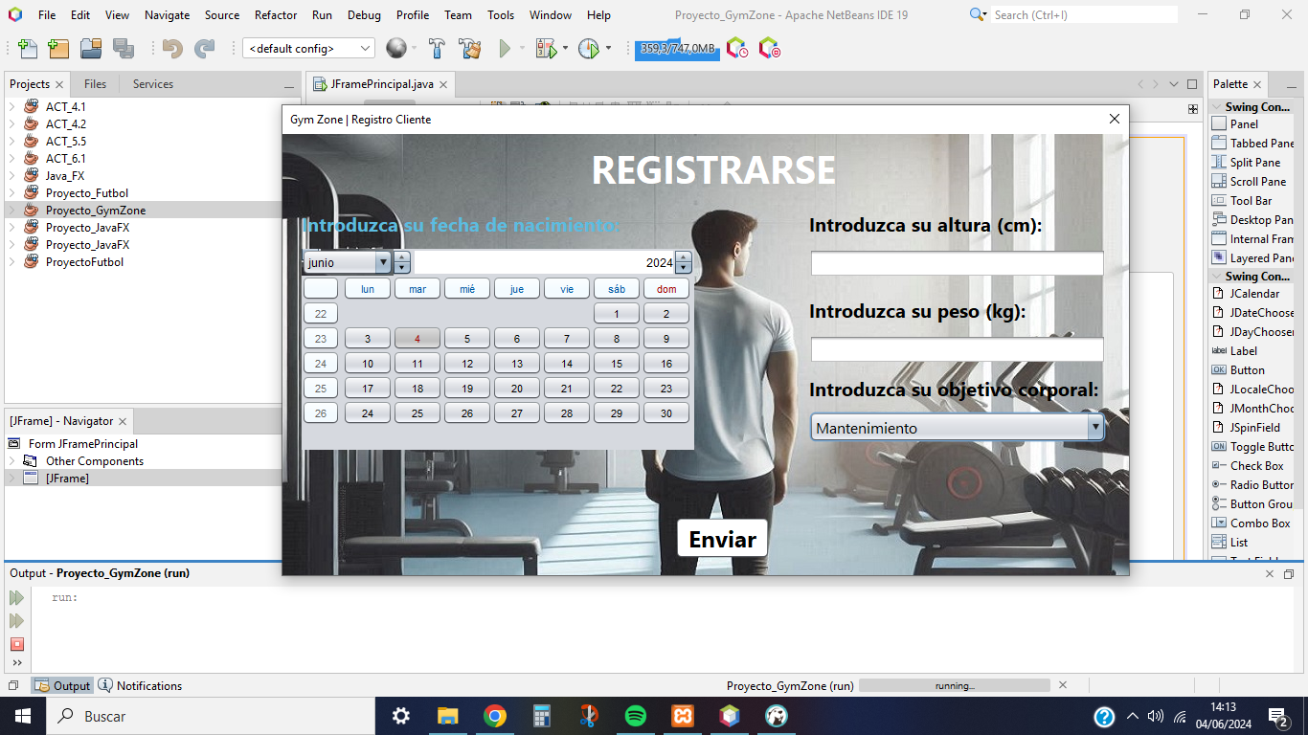

* Nutritionist registration: displays a form where the nutritionist chooses the type of diet to manage.displays a form where the customer fills in his personal and body data.

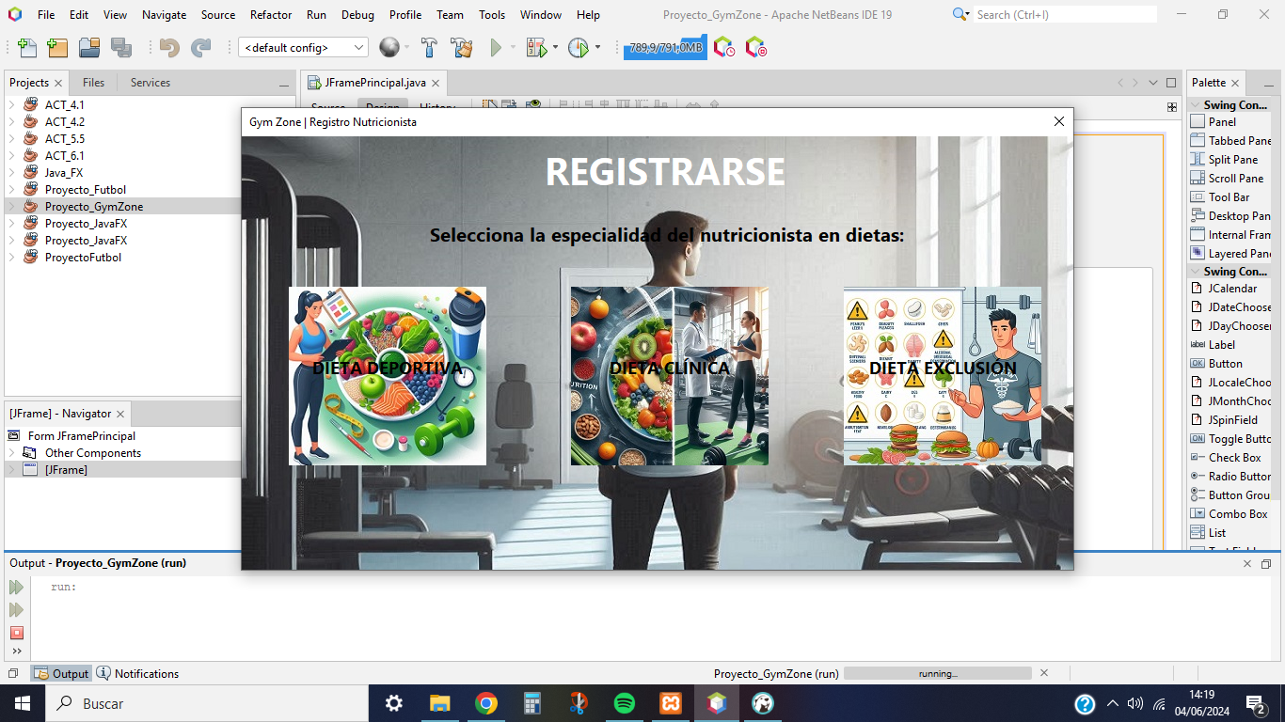

* Monitor registration: displays a form where the monitor chooses the type of routine to manage.

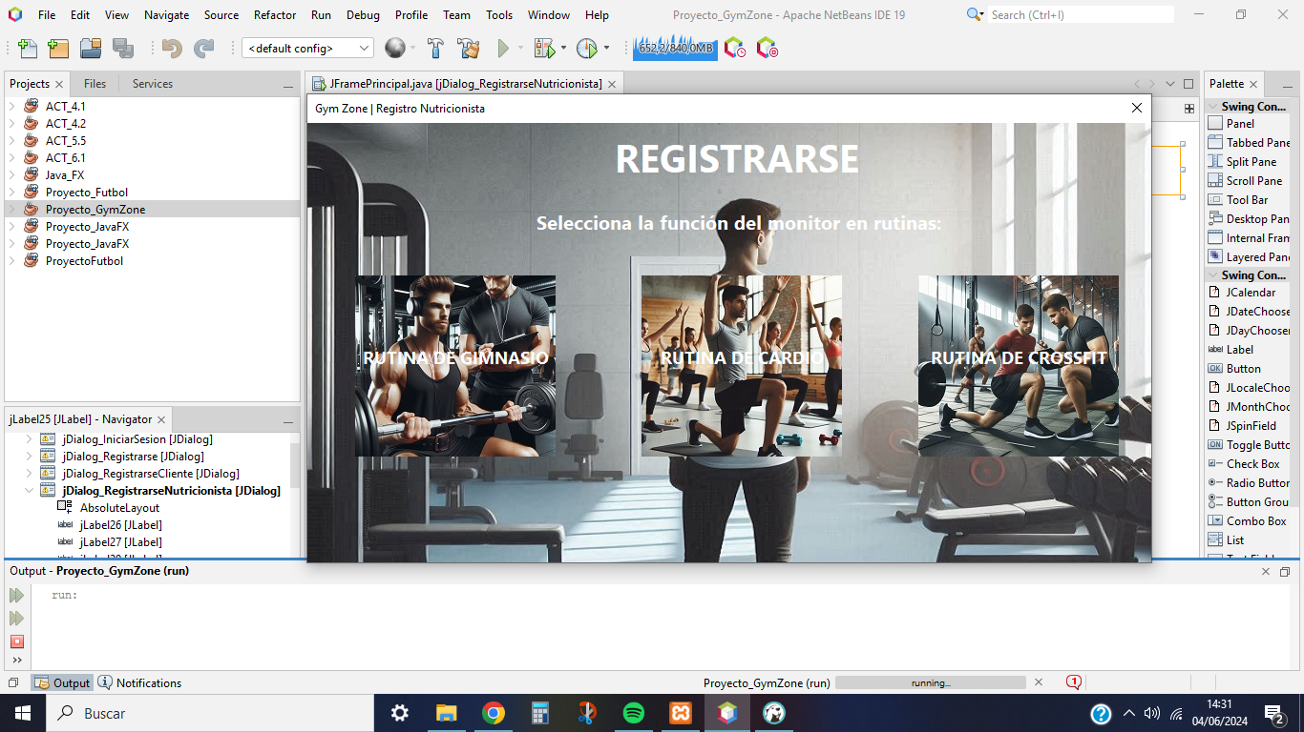

## **User Profile**

The user's screen allows the display of his data registered in the system with the possibility of modifying them.

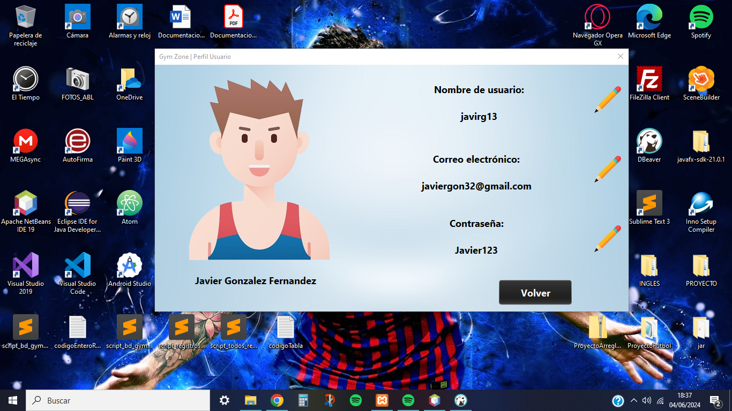

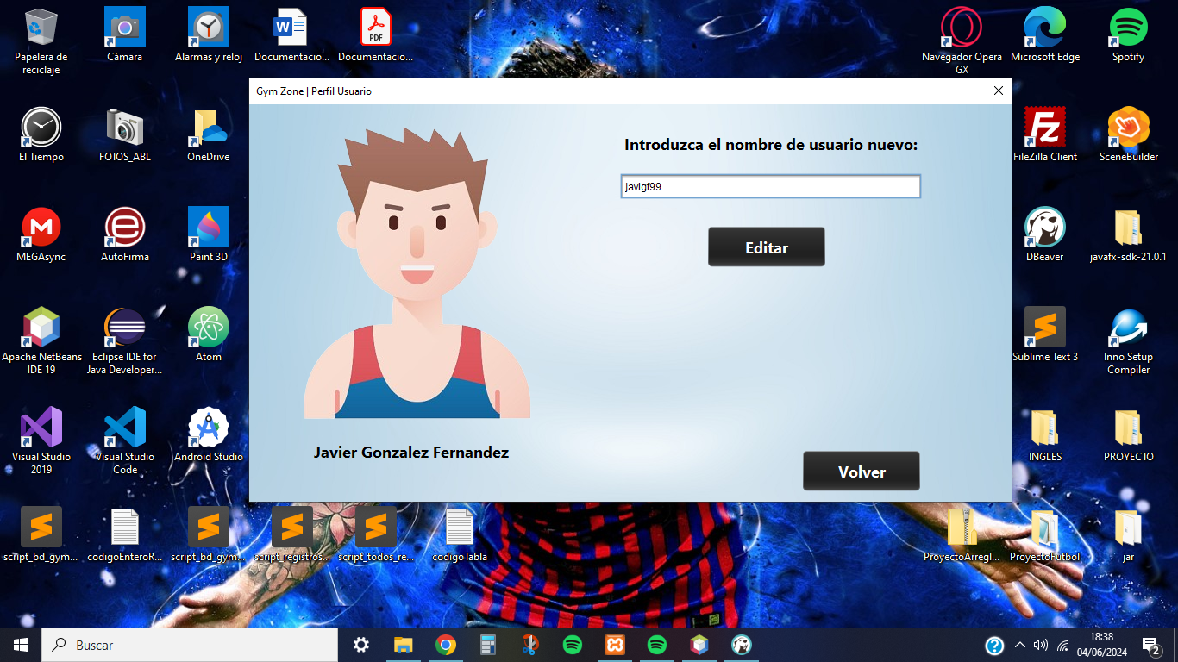

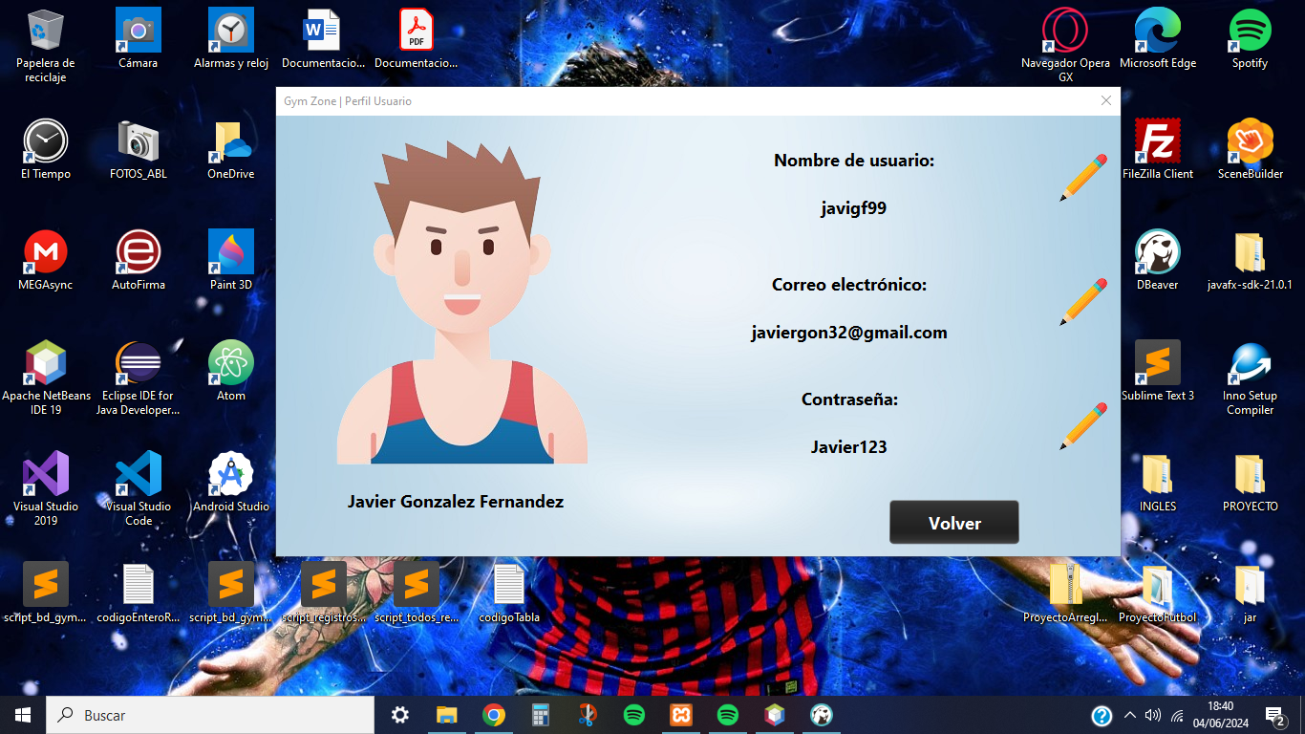

## **Bank Account Management**

This last main screen allows you to manage the bank account you wish to register in the system. In case you have registered the account, it allows you to consult it or delete it directly.

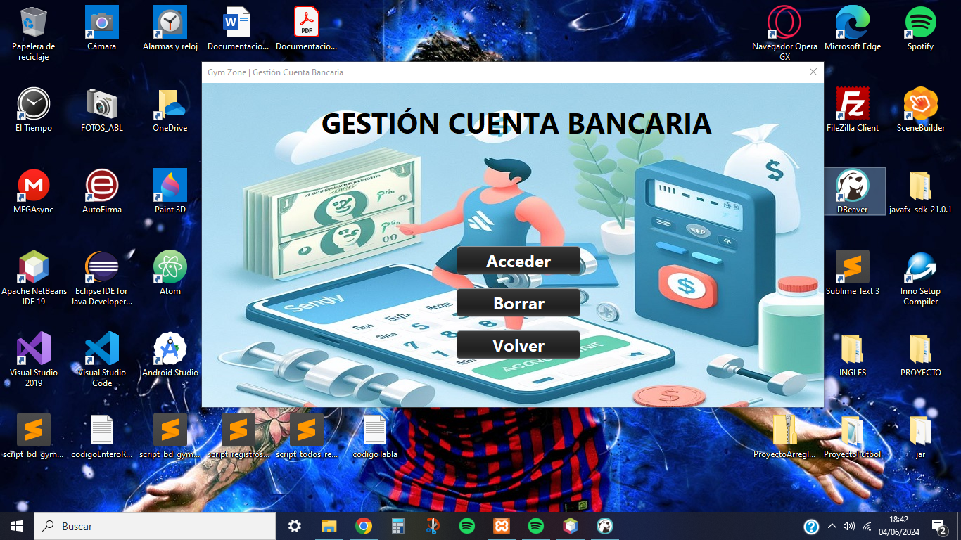

When the user consults the bank account, the registered data and the possibility to modify it by clicking on the image of the type of bank that is associated with the account will appear. In addition, you can make deposit or withdrawal operations of the balance you have, always making sure that it is not in negative balance.

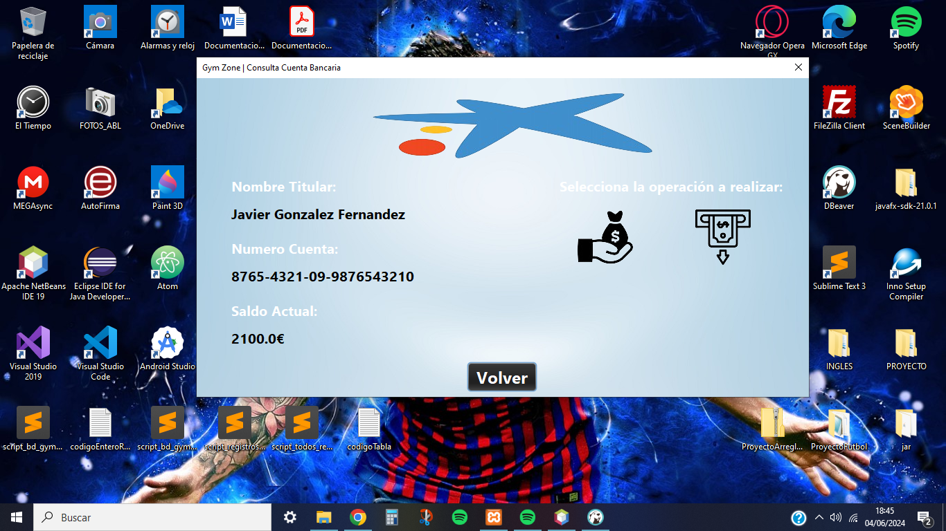

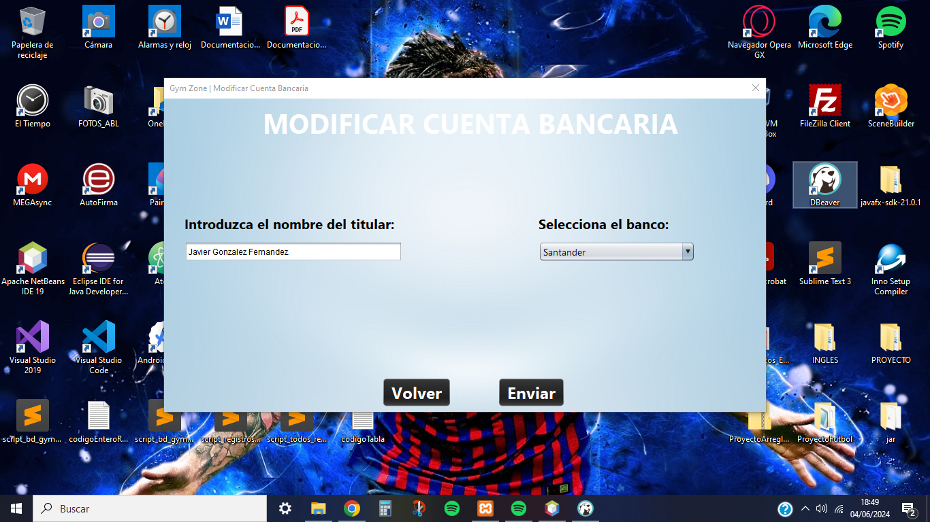

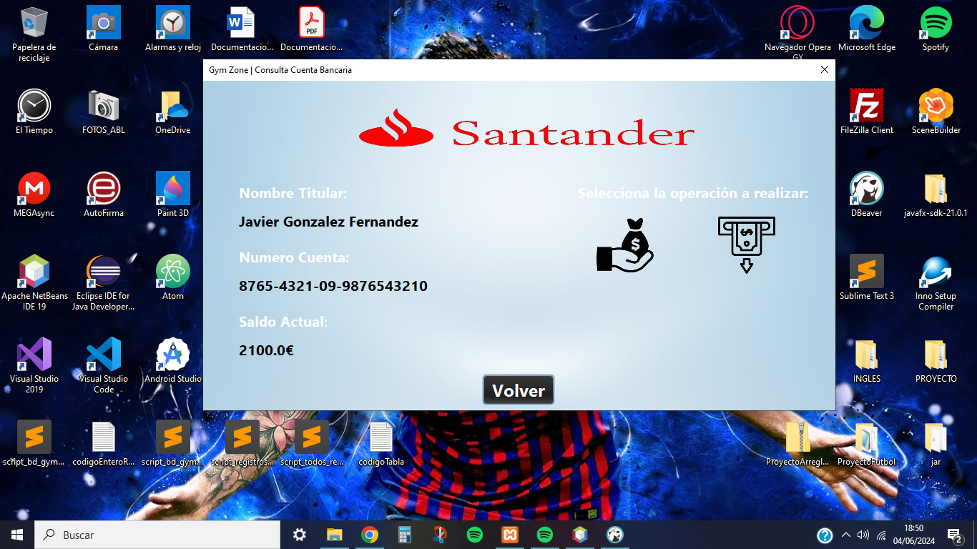

Finally, in case you do not have a registered bank account, the screen gives the possibility to register the account with its corresponding data.

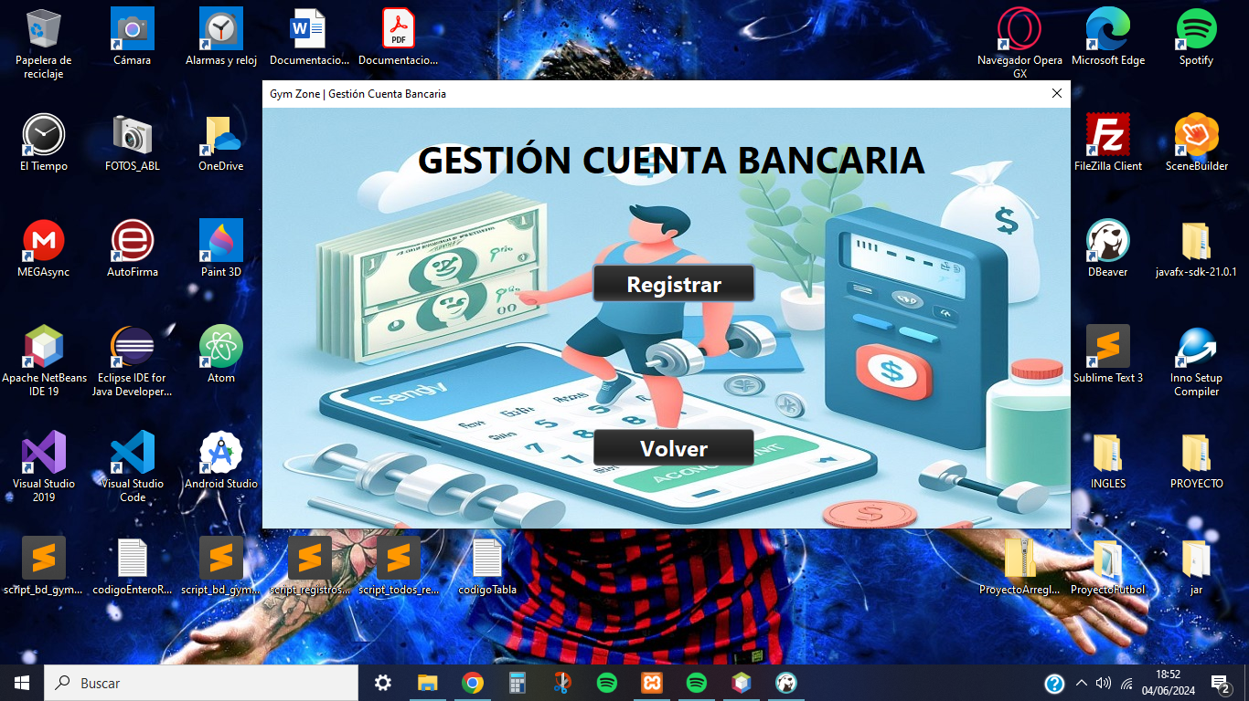

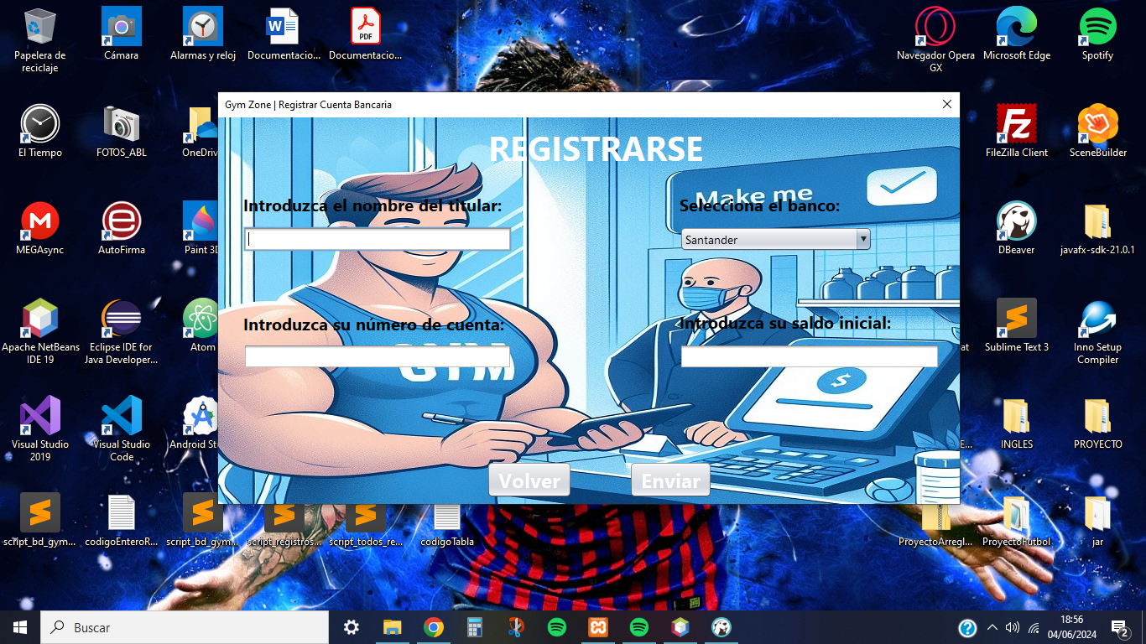

# **Monitor functions**

The screens that will be used by the monitors to manage routines in the application will be detailed below, providing clear and precise instructions on how to use each one of them.

The user must have chosen the Monitor role and be logged in with the corresponding account to have access to these functionalities.

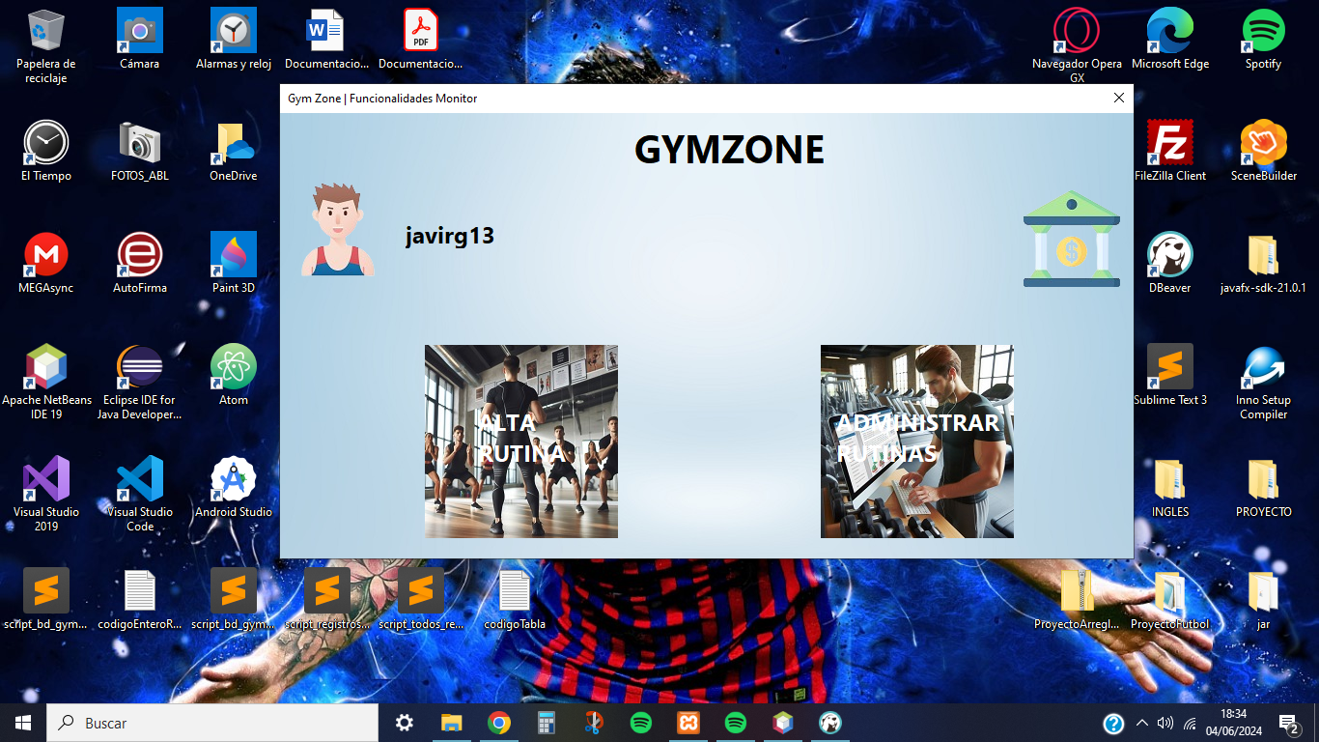

## **Create Routine**

This functionality of the monitor allows you to create routines where you must indicate the name, number of days that the routine is performed and the type of objective.

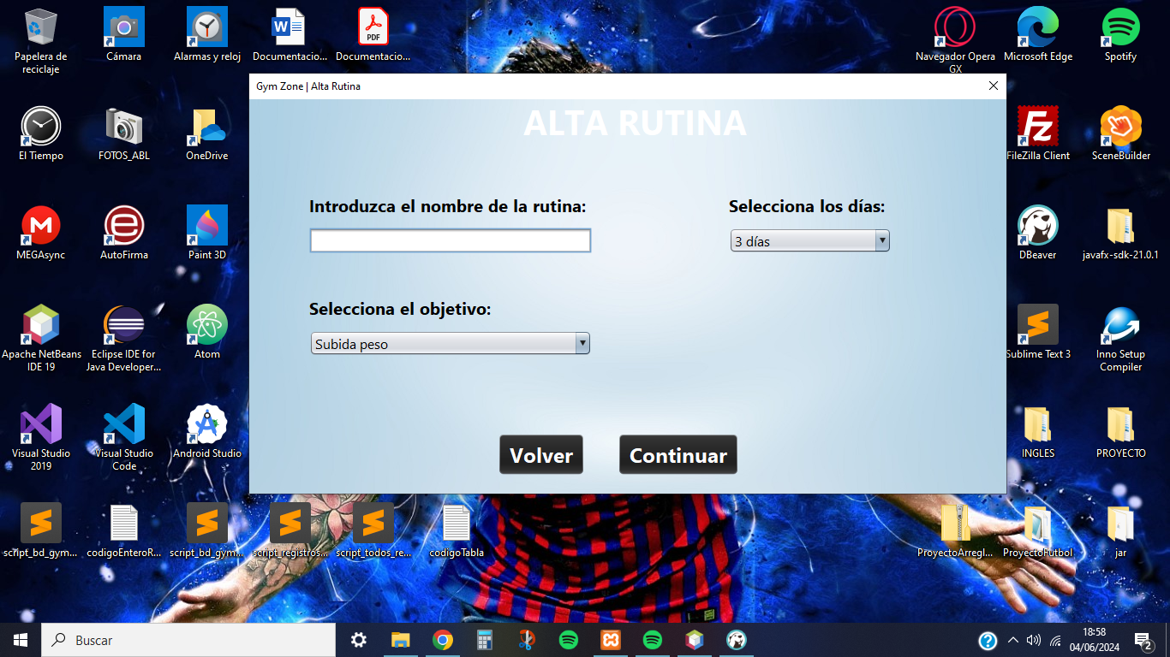

Also, you must select at least 5 exercises per day where the instructor can filter the exercises by the muscle group (Leg, Chest, Back, Abdominals, Arm) to be worked.

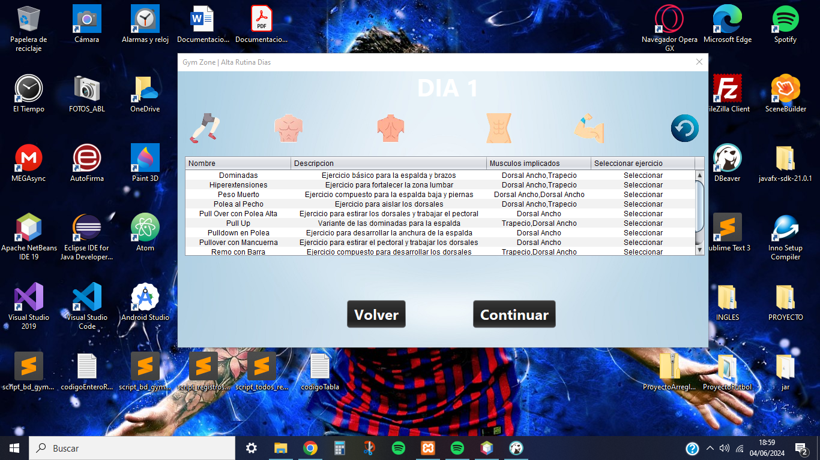

## **Routine Management**

This last functionality of the monitor allows you to consult, modify and delete the routines carried out by all the gym instructors through the table.

Additionally, you can filter this table by name, goal type, and the creator of said routine.

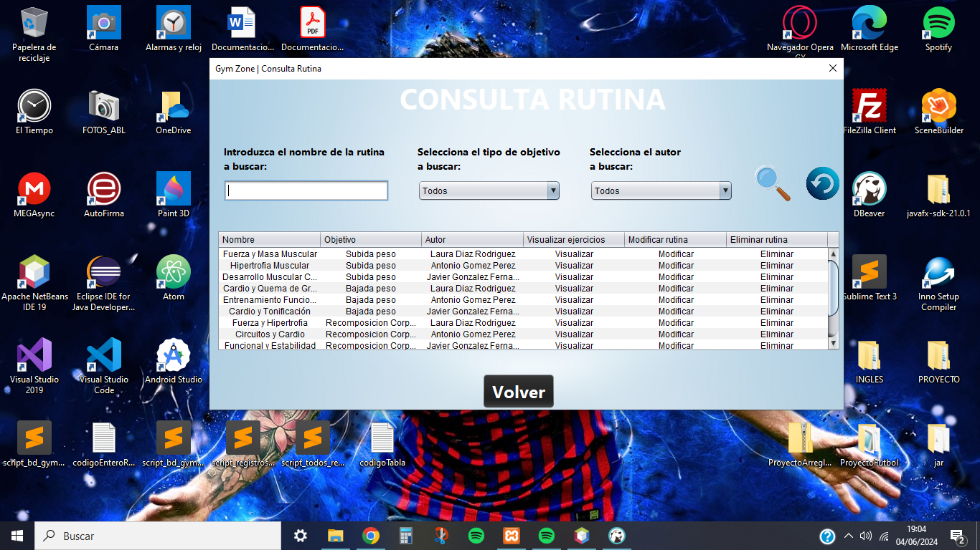

In case you have selected the routine to visualize its respective exercises, the system will show an alternative screen where it will display in a different table the exercises of each day's routine.

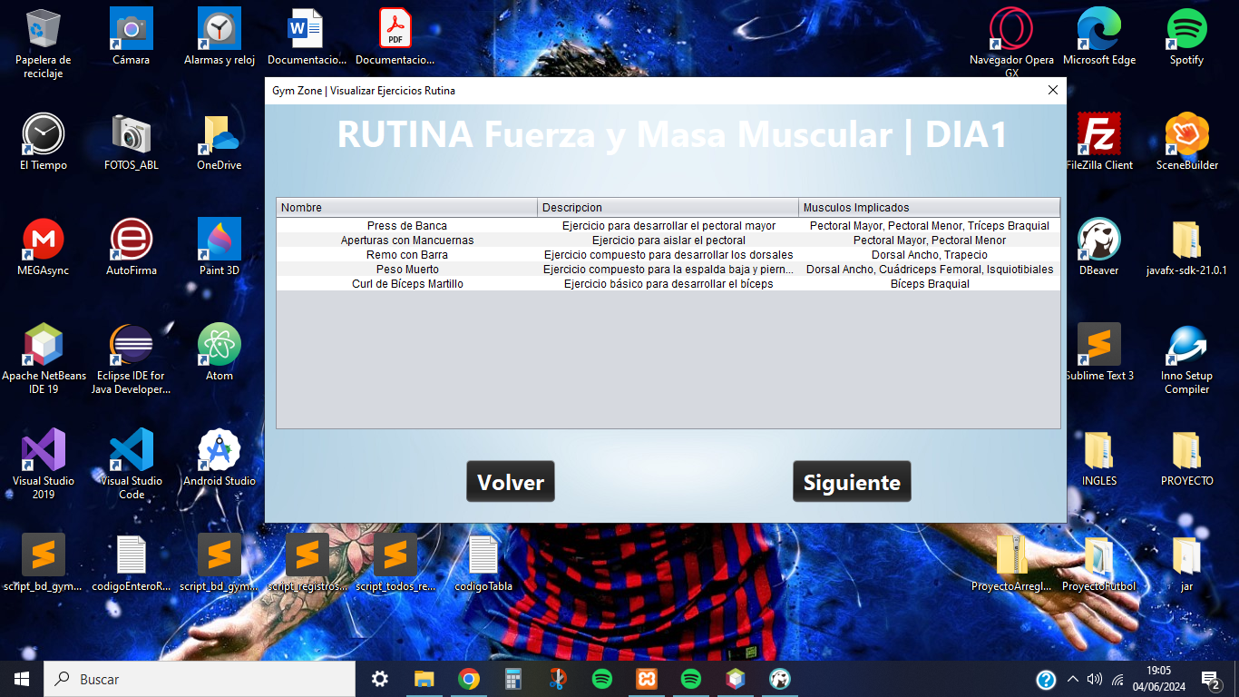

In case you have selected the routine to modify its respective data, the system will display an alternative screen where it will show in a form the registered data and the monitor will have to modify them.

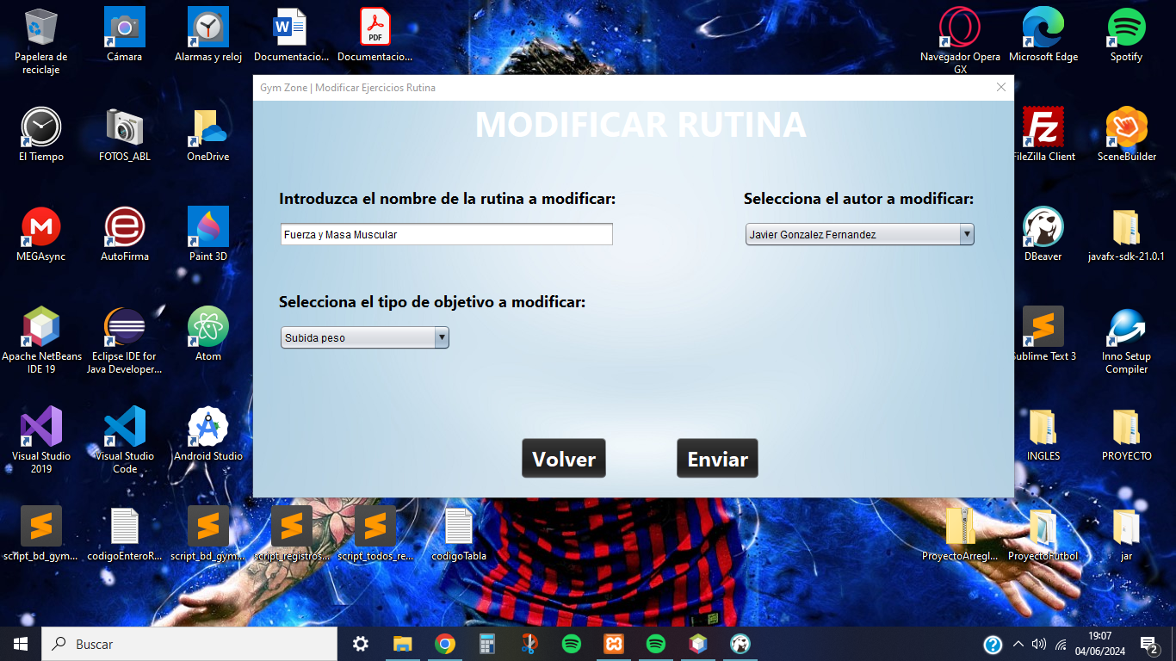

In case you have selected the routine to be deleted, the system will delete the selected routine and notify the monitor that it has been successfully deleted.

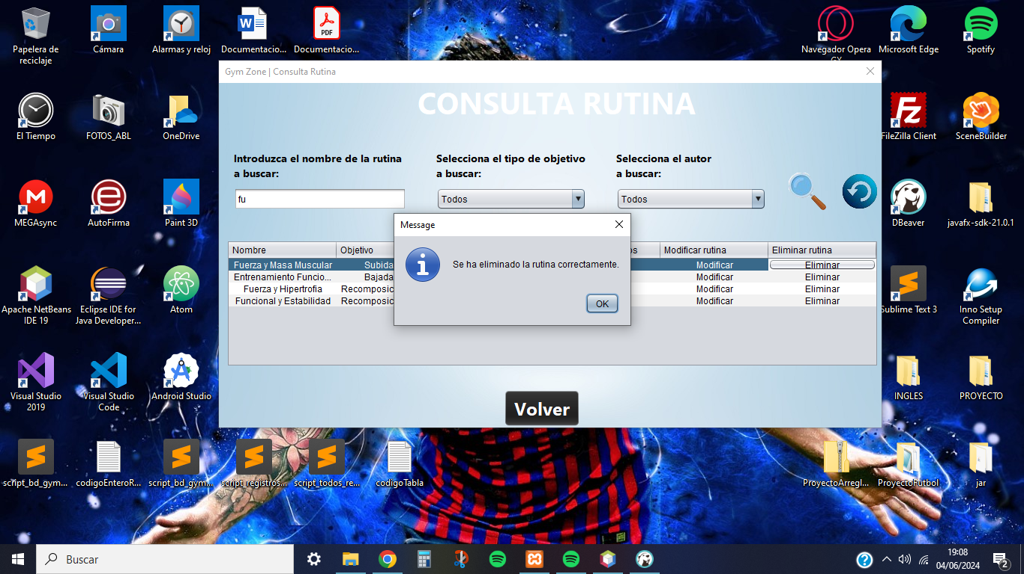

# **Nutritionist functions**

The screens that will be used by nutritionists to manage the application's diets will be detailed below, providing clear and precise instructions on how to use each screen.

The user must have chosen the Nutritionist role and be logged in with the corresponding account to have access to these functionalities.

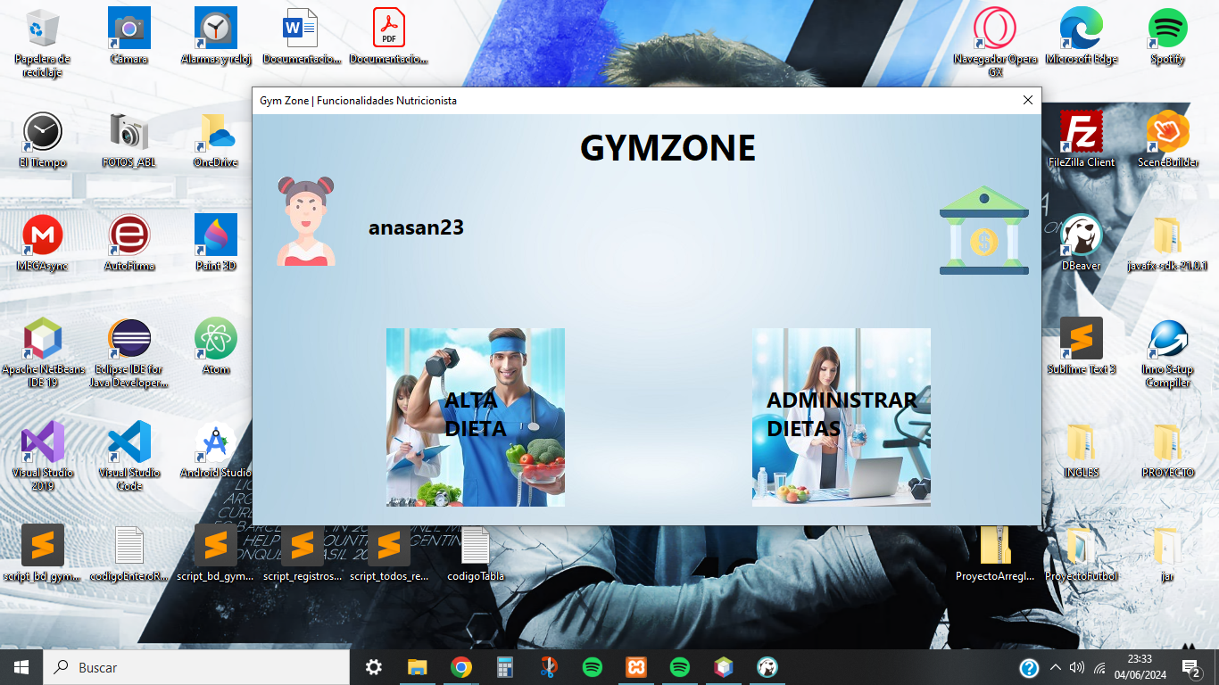

## **Create Diet**

As well as the functionality of the monitor, the nutritionist must indicate the name, number of days and objective of the diet. Especially with respect to the routine, a short description of the diet should be indicated.

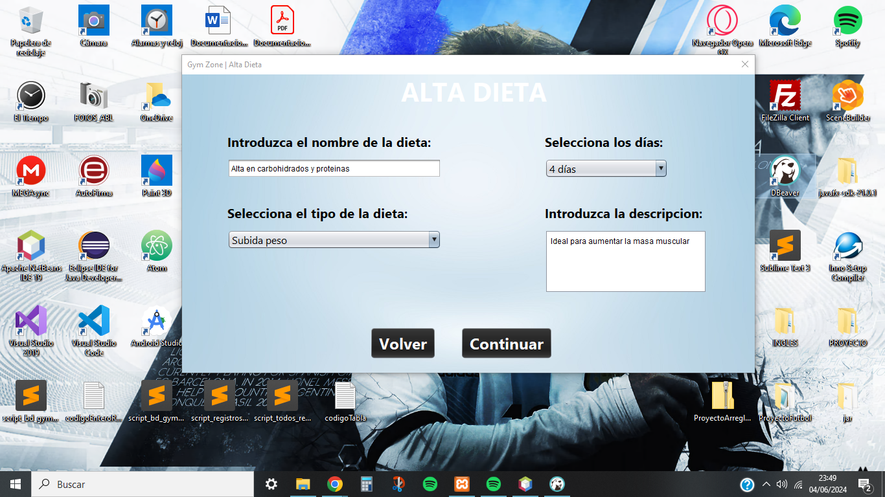

Finally, to create the diet, the nutritionist must select for each meal of the day (Breakfast, Lunch, Snack and Dinner) a minimum of 2 foods. These can be filtered by food group (Fruits, Vegetables, Carbohydrates, Proteins, Dairy products, Fats and oils and Sugars and sweets).

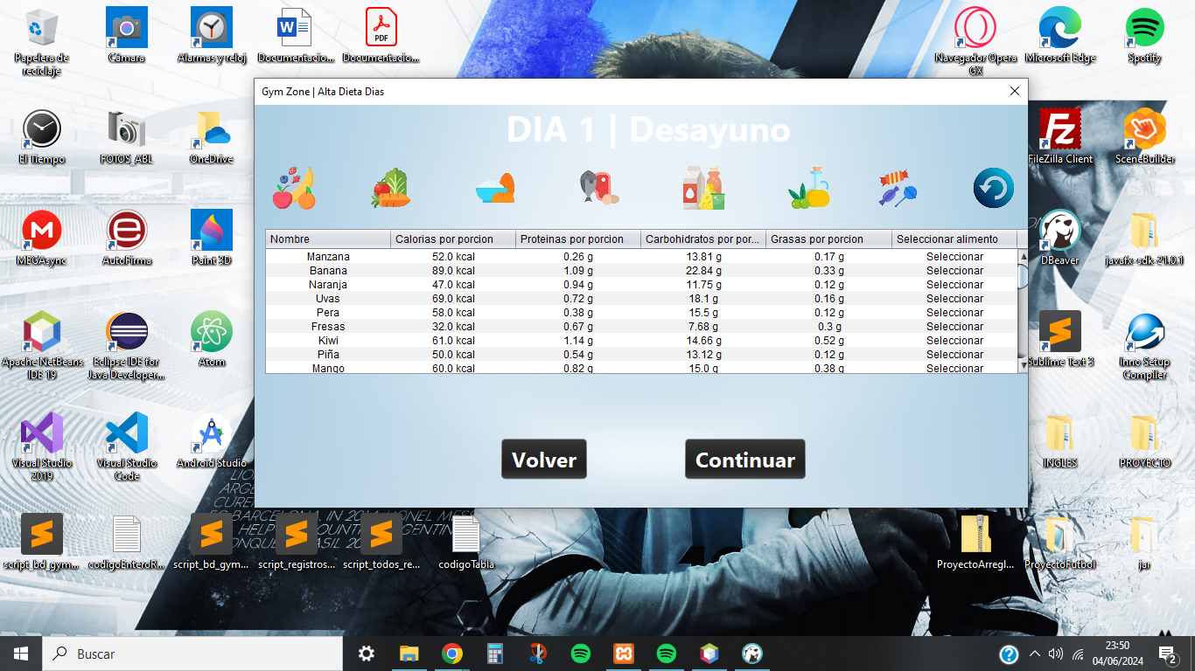

## **Diet Management**

As in routine management, we will see a table where in this case shows all the diets that have been made by the nutritionist where we can filter by name, type of goal or the creator of the same.

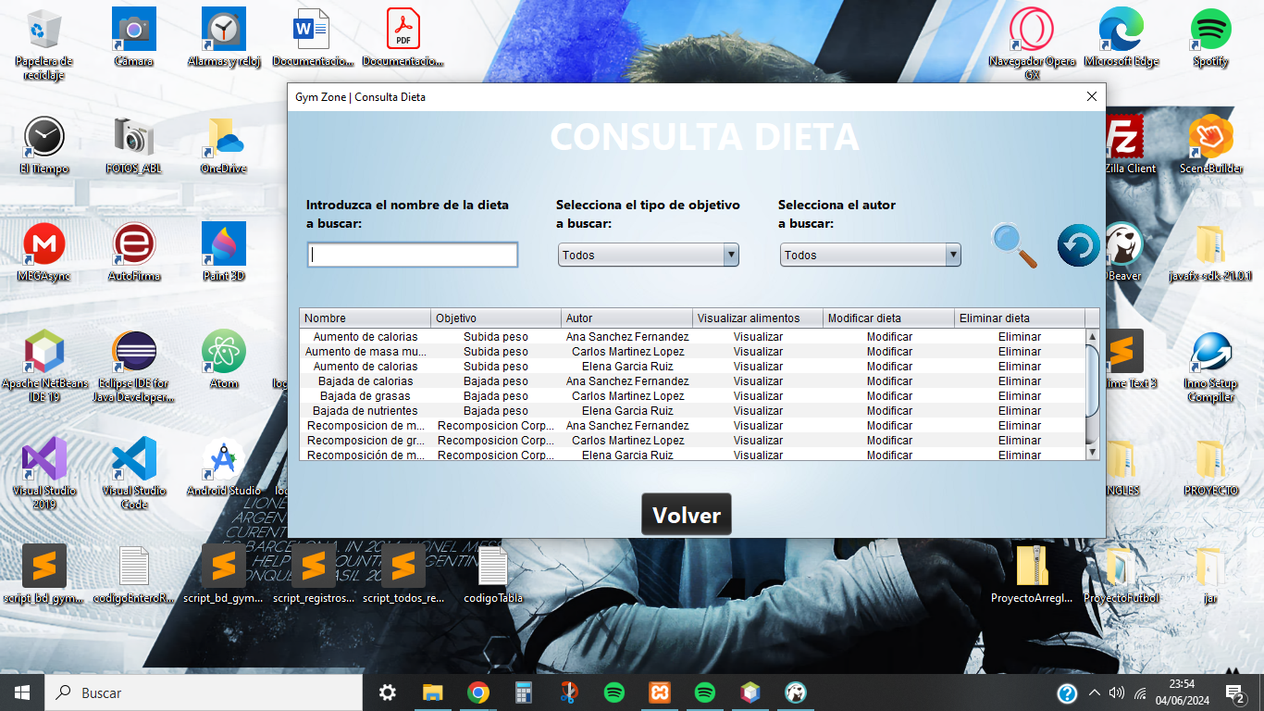

In case you have selected the diet to display their respective meals, the system will display an alternative screen where it will show in a different table the foods of each meal in its corresponding day.

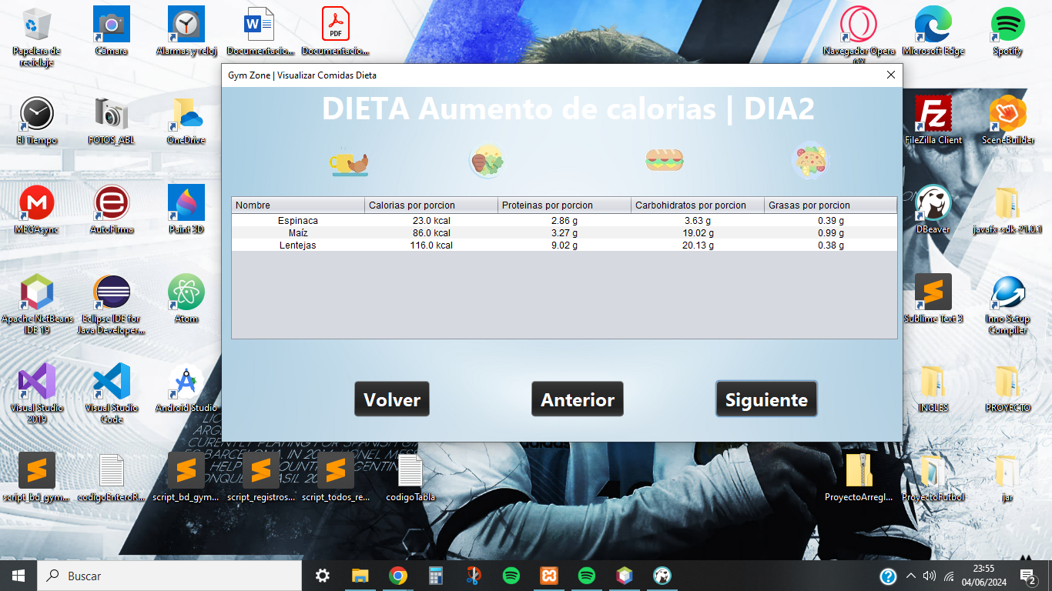

In the case of having selected the diet to modify its respective data, the system will display an alternative screen where it will show the registered data and the nutritionist will have to modify them.

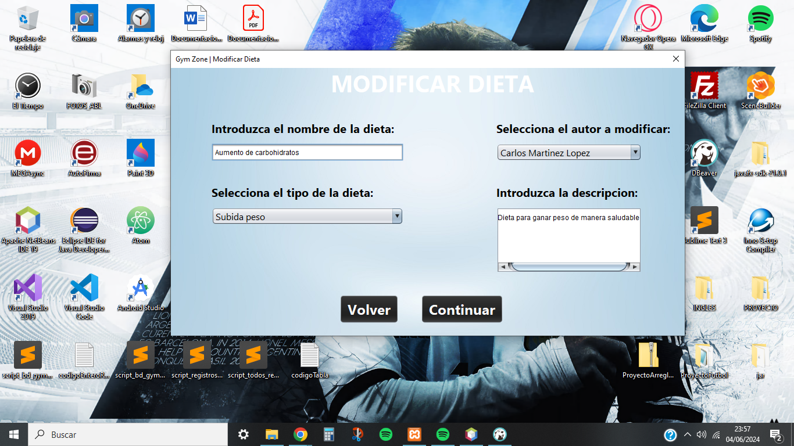

In case you have selected the diet to be eliminated, the system will delete the chosen diet and notify the nutritionist that it has been successfully eliminated.

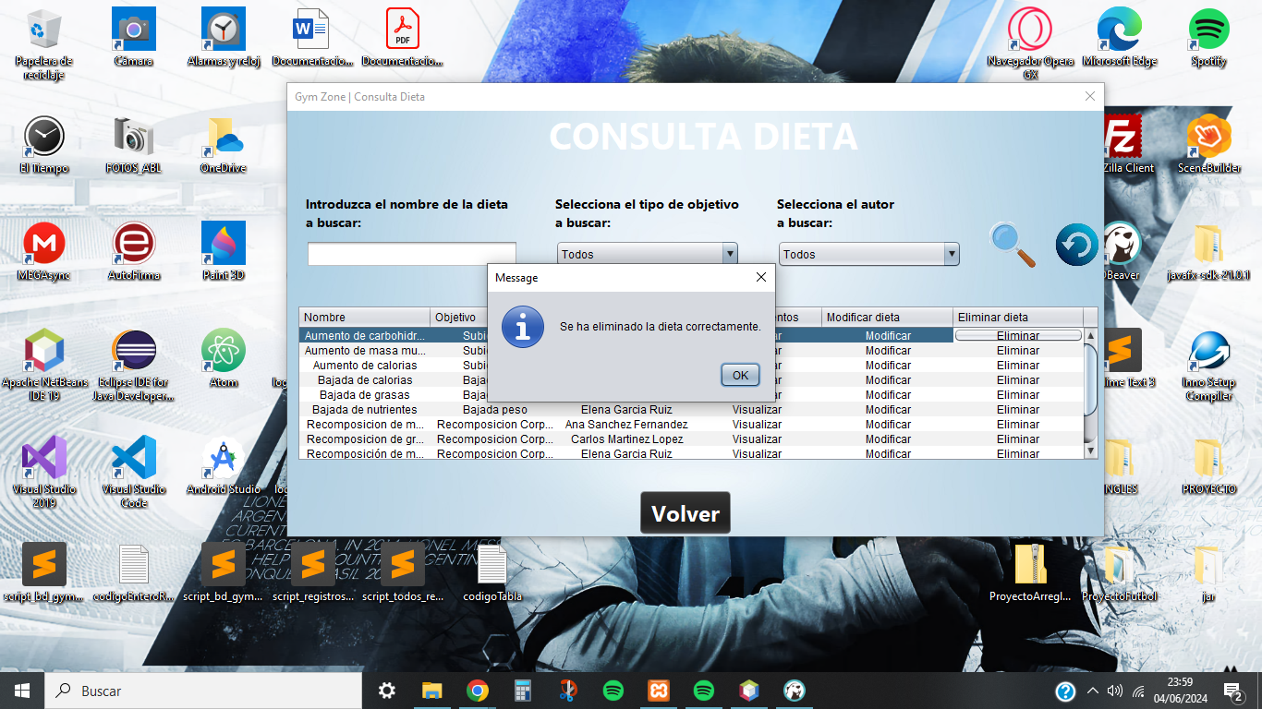

# **Administrator functions**

Below are the screens that administrators will use to manage the different functionalities of the gym, providing clear and precise instructions on how to use each screen.

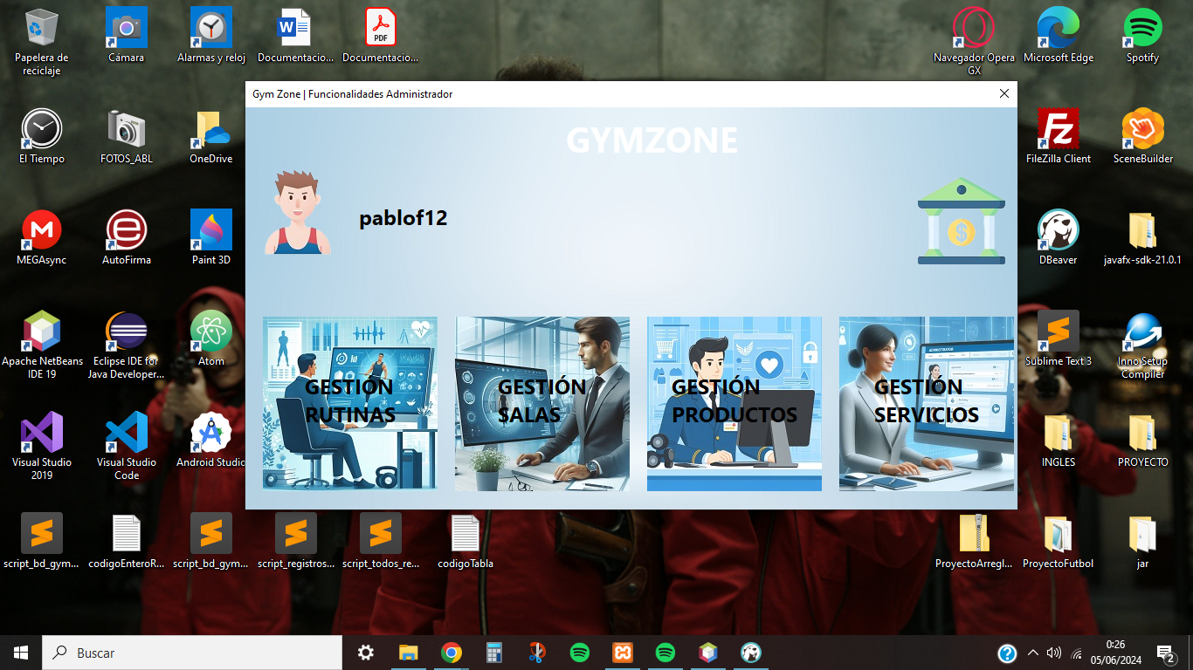

## **Routine Management**

The administrator, being also a monitor, has access to the same functionalities as this type of user, where he can create and manage routines.

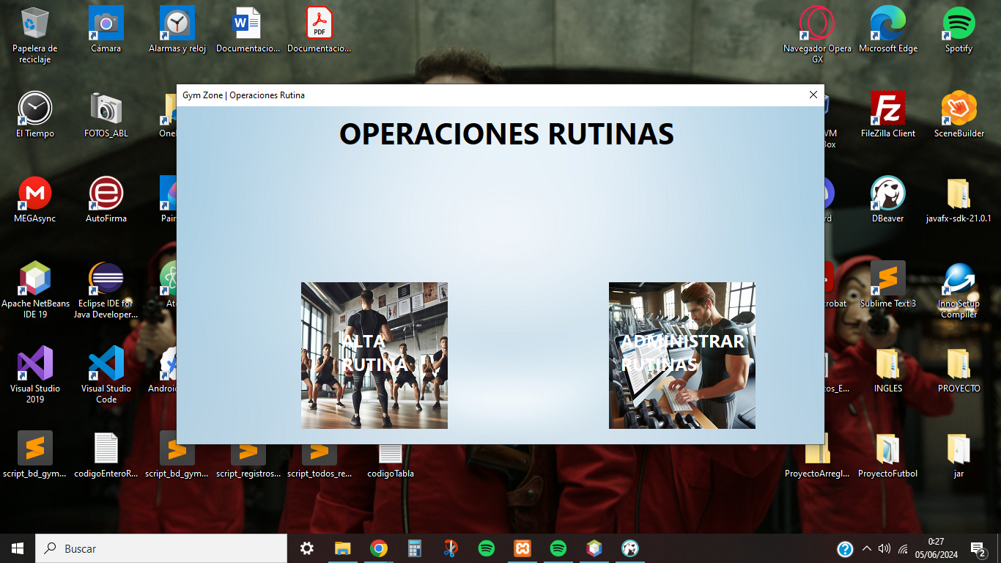

## **Room Management**

This screen allows you to manage and view everything about the specific rooms of the gym.

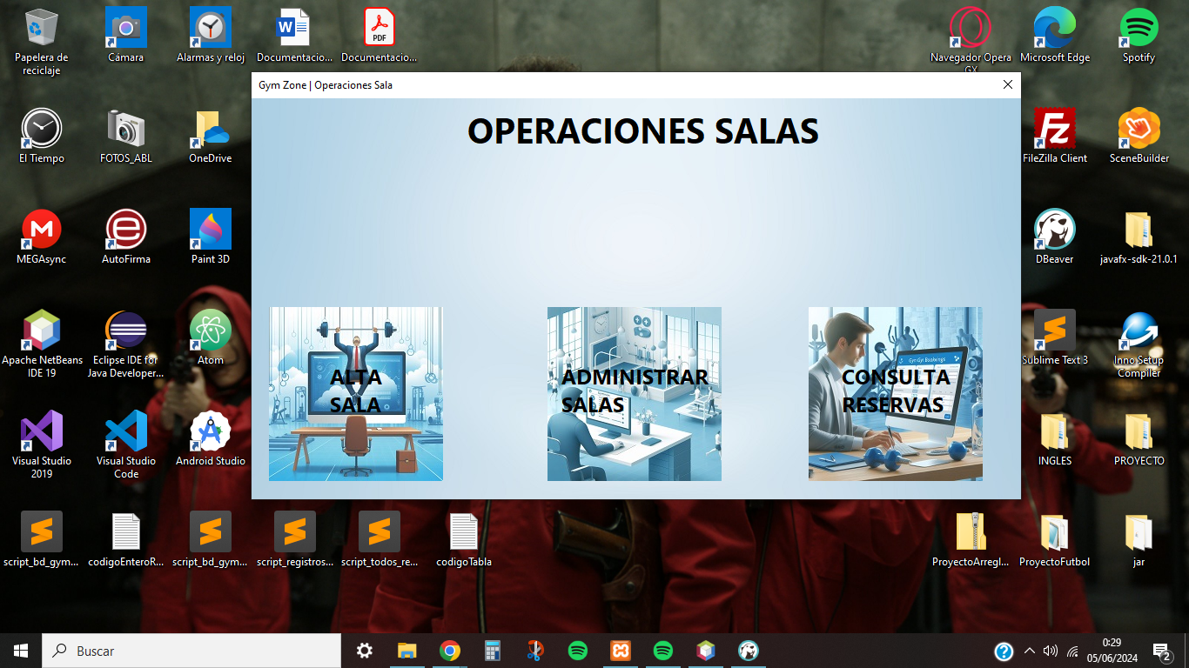

These are the functionalities that this screen allows to manage the rooms:

* Create room: this type of user can create the desired rooms where he must indicate the name, the monitor or not assigned to it and the maximum capacity of people that the room can have.

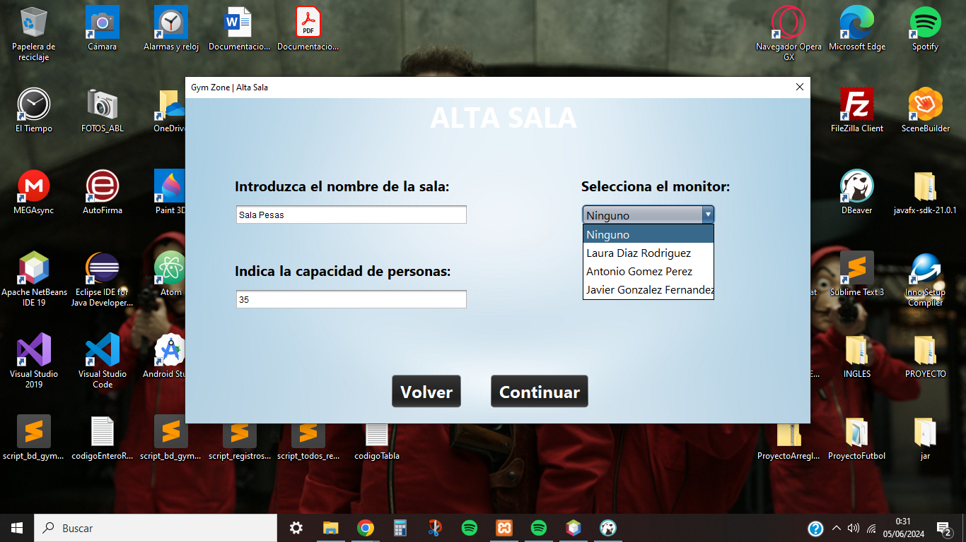

* Room management: this window, similar to the previous ones, displays the rooms registered in the system where the administrator can filter by name, capacity or monitor assigned to the room. Also, he can modify the desired data and delete it.

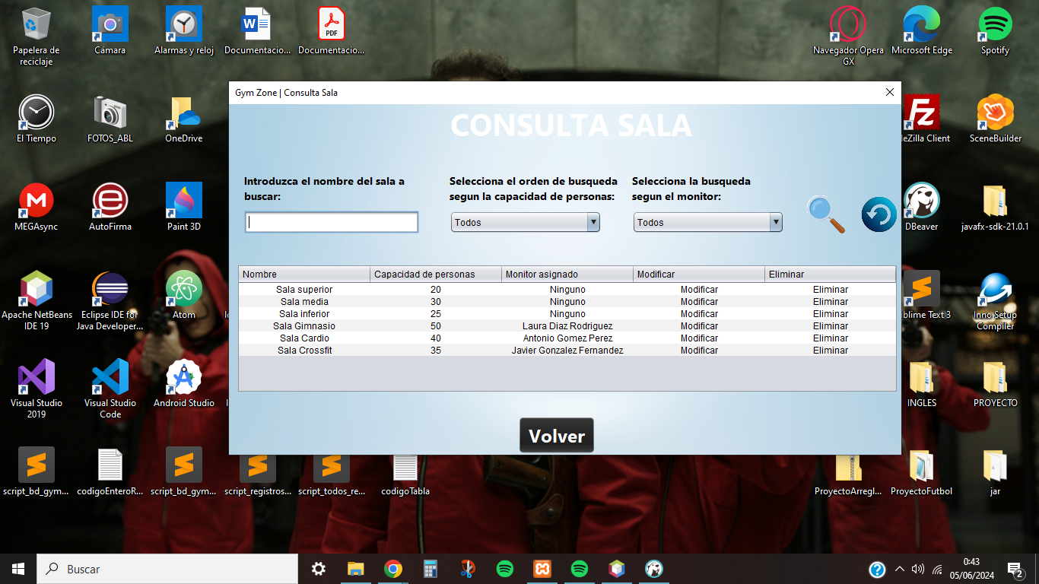

* Consult reservations: this window allows you to view all reservations made by customers on the current day, as the system deletes all reservations from previous days. Also, you can filter by the room that has been booked, the client, date and shift (morning or afternoon).

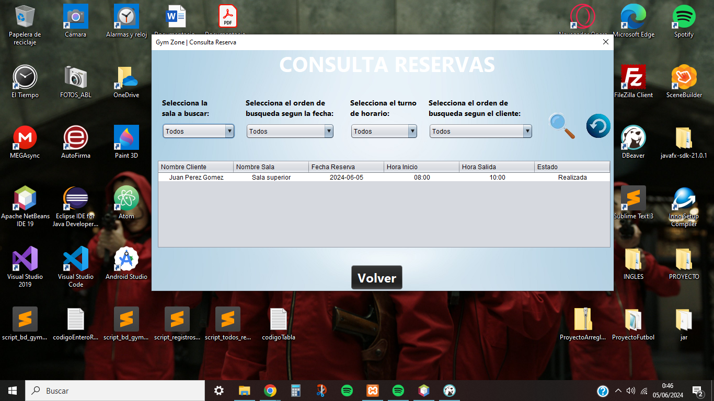

## **Product Management**

This screen allows you to manage and view everything about the specific products of the gym.

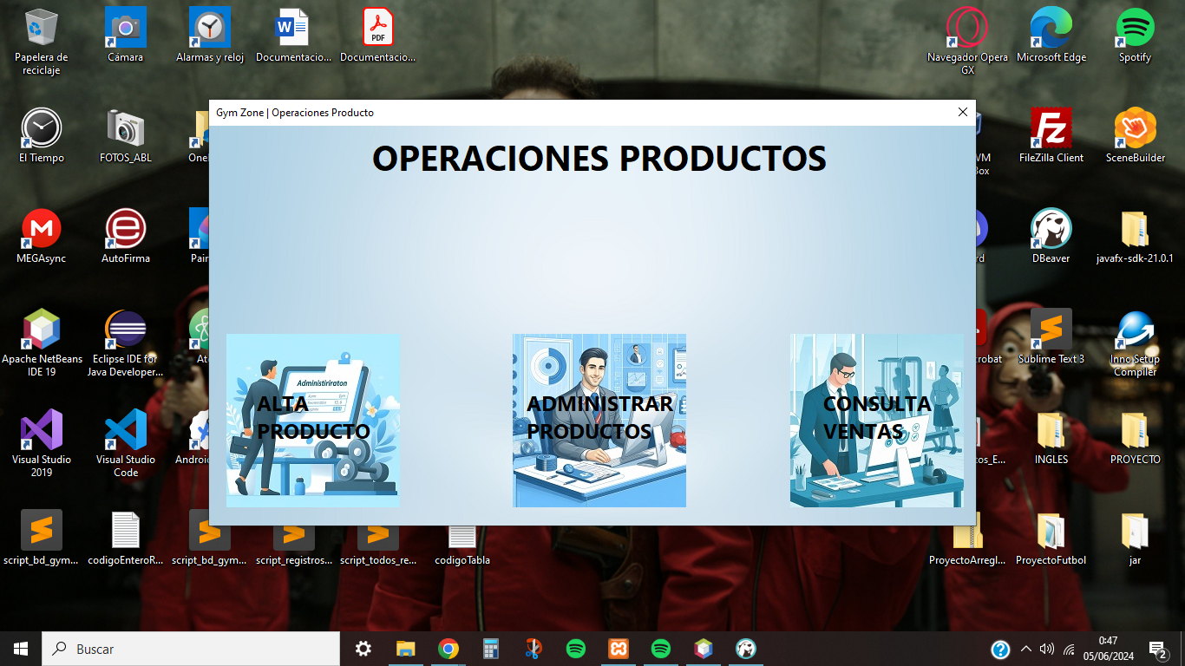

These are the functionalities that this screen allows to manage the products:

* Create product: the administrator can create as many products as he wishes, indicating the name, the initial quantity and the unit price.

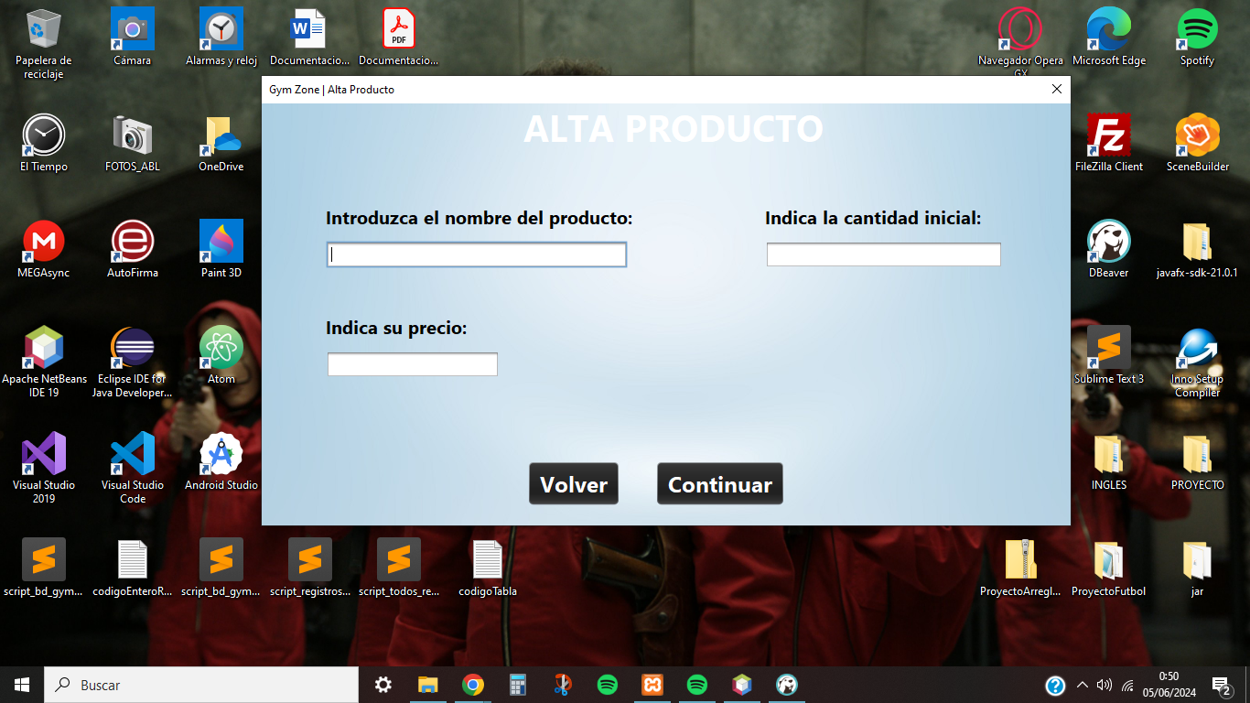

* Product management: this window, similar to the previous ones, shows the products registered in the system where the administrator can filter by name, price or quantity available. In addition, he can modify the desired data and delete them.

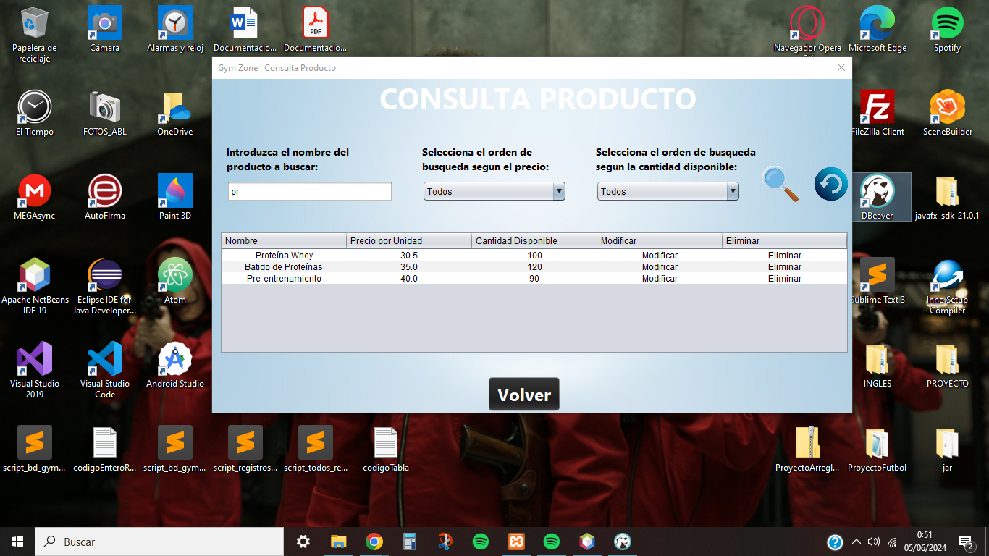

* Consult sales: this window allows you to view all sales made by customers, where you can filter by the name of the product sold, date of the sale and the name of the customer who bought the product.

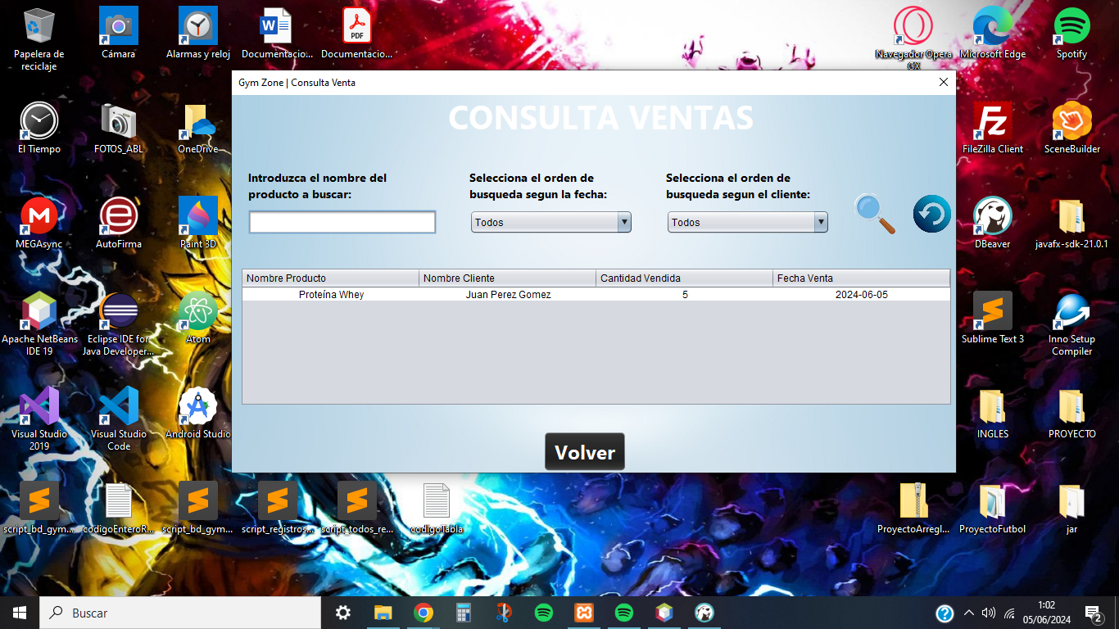

## **Service Management**

This screen allows you to manage and view everything about the specific services of the gym.

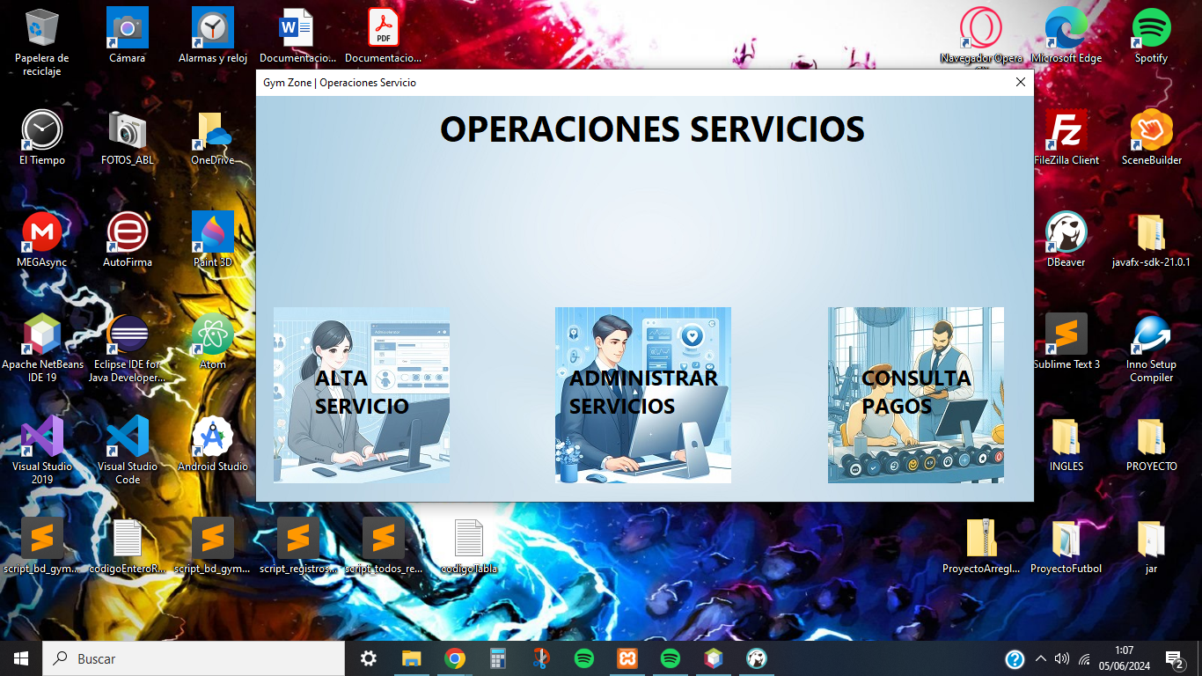

These are the functionalities that this screen allows to manage the services:

* Create service: the administrator can create as many services as he wishes, indicating the name, price and the number of days of the service duration. When the service reaches the expiration date, it will automatically change to the Canceled status.

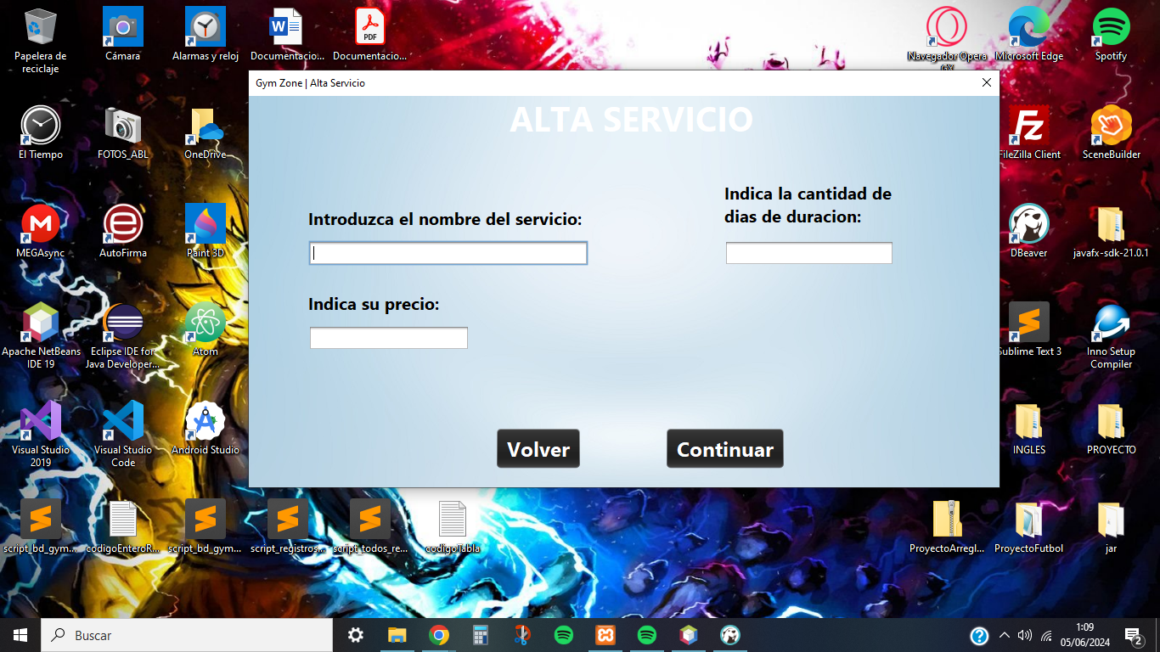

* Service management: This window, similar to the previous ones, shows the services registered in the system where the administrator can filter by name, price or number of days.

In addition, he can modify the desired data and delete them, except for the main services (Gym, Monitored Training, Diet Consultation, Routine Consultation) which are essential for the correct use of the application.

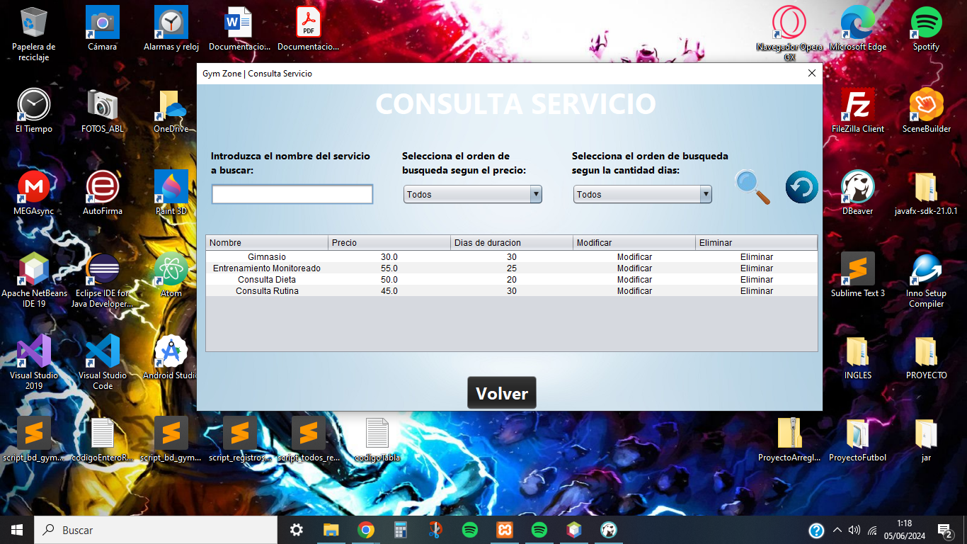

* View service payments: this window allows you to view all service payments made by customers, where you can filter by the name of the service paid for, the date of payment (indicates the expiration date of the service) and the name of the customer who purchased the product.

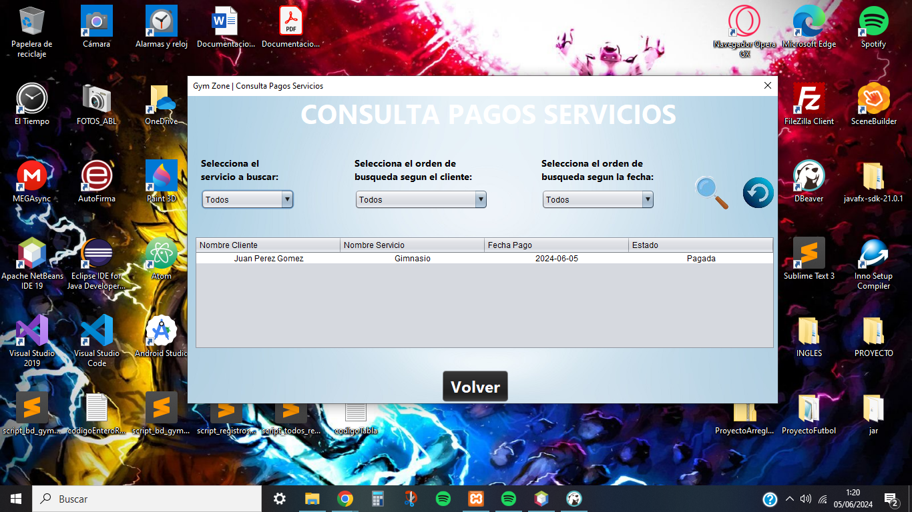

# **Customer functions**

This section shows the screens that customers will use to make use of the different functionalities of the gym, providing clear and precise instructions on how to use each screen. Customers have a multitude of exclusive functionalities which will be detailed below.

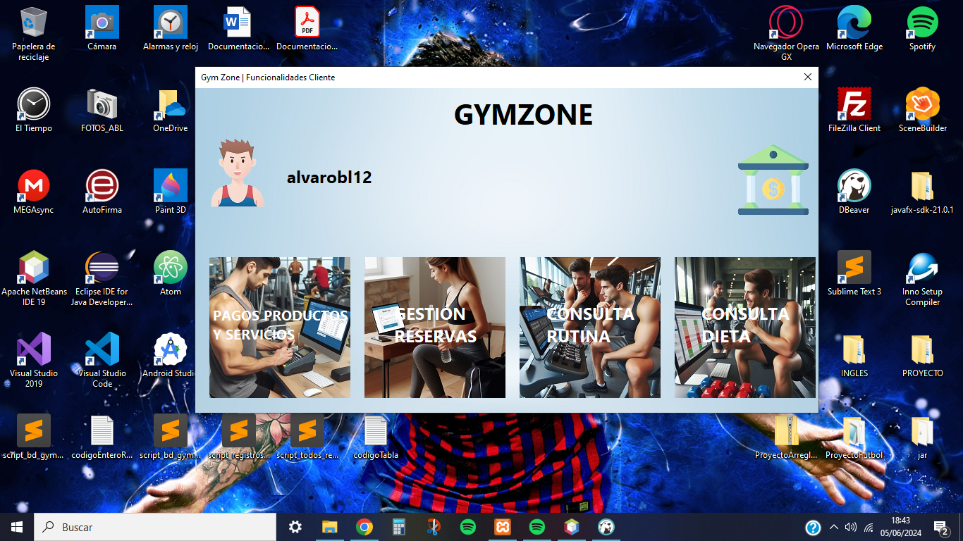

## **Customer Data Query**

All customers have one more functionality compared to the rest of the users regarding the user profile where they can access to visualize their personal and body data.

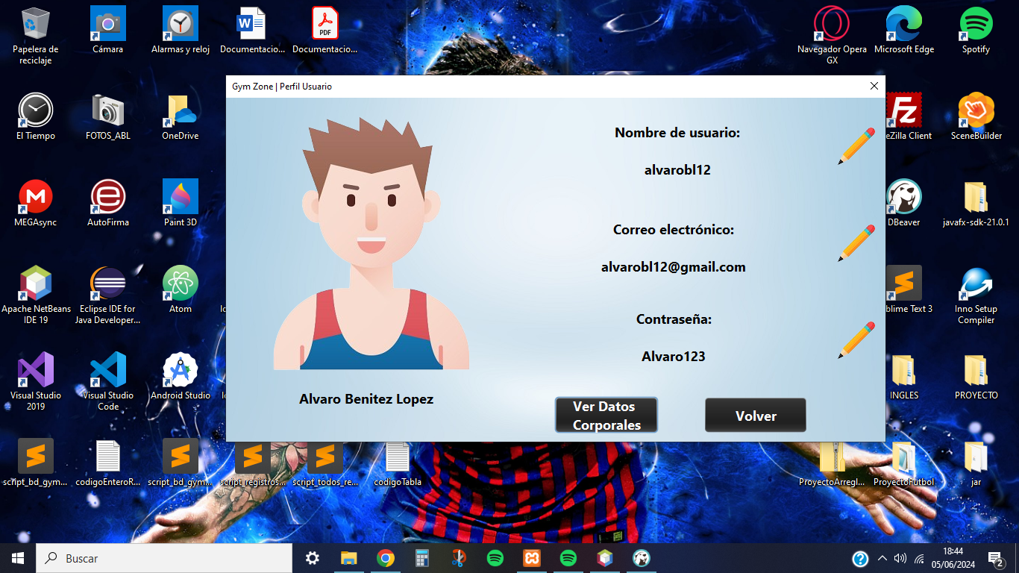

In this screen, the client can edit his body data (body objective, height and weight). In particular, if the client edits the body objective when paying for the routine or diet service, these will be changed according to the body objective he wishes to achieve.

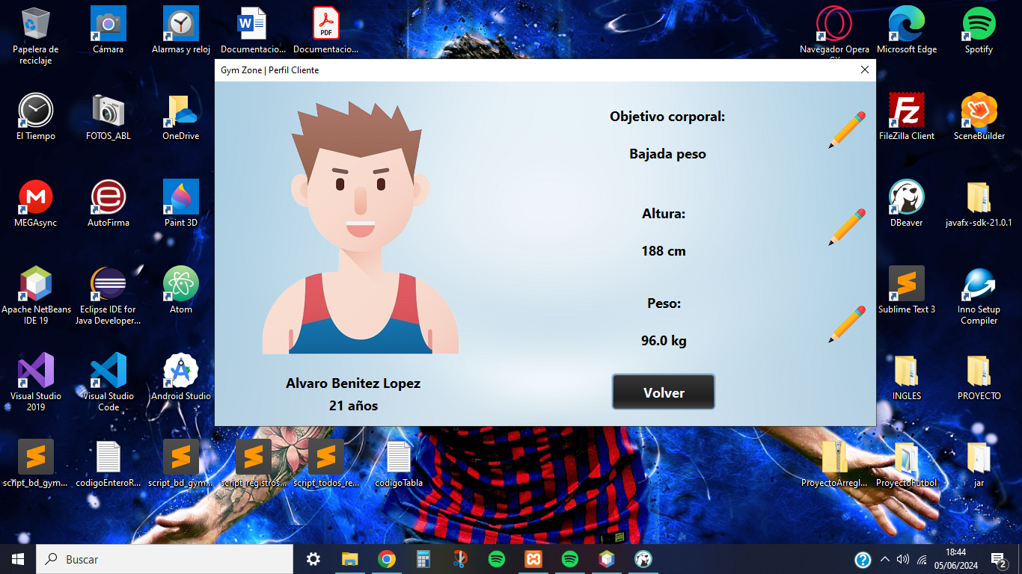

## **Payments Products and Services**

This functionality is one of the most important, focusing on the payment of services, since it will allow the client to use the rest of the functionalities (Reservation Management, Routine Consultation, Diet Consultation) if he has paid for the respective service.

The client must have a registered bank account in order to access this functionality and perform the desired transactions, when logged in he will be able to pay for products and services available from the gym.

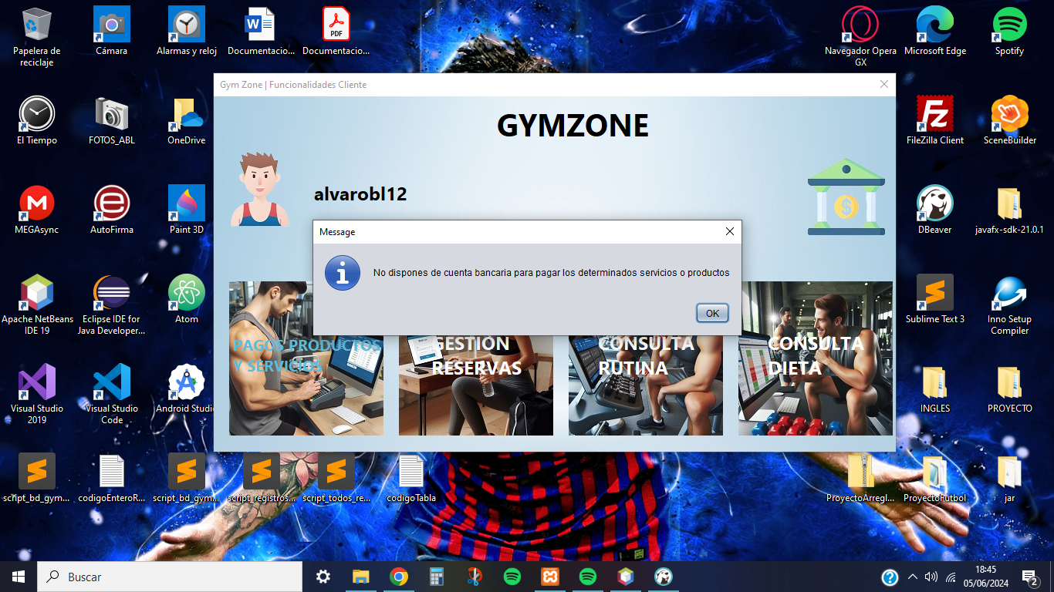

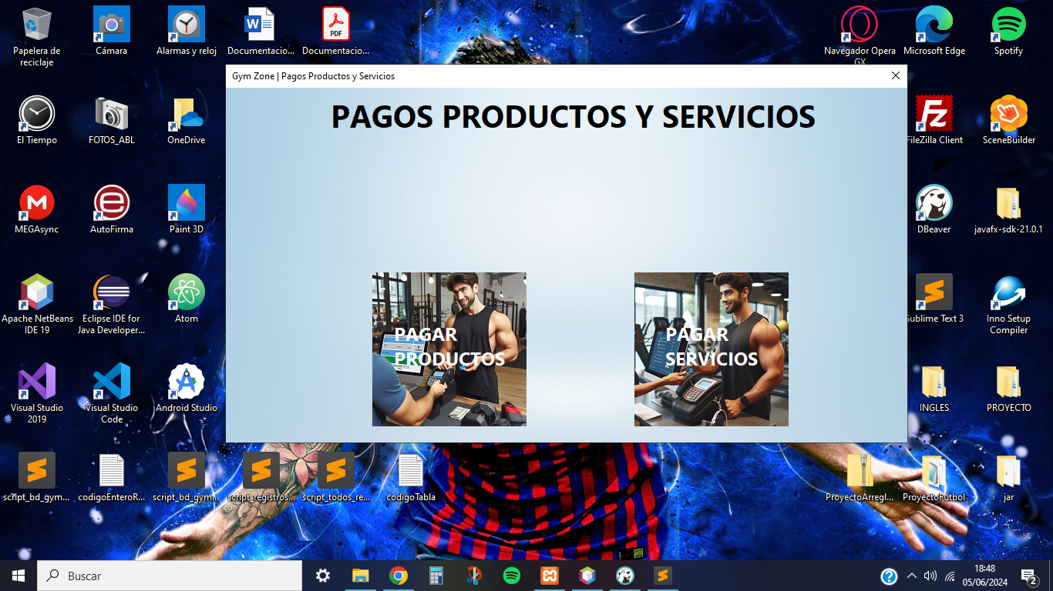

In the section to pay for products, the customer will be able to purchase the desired quantity of the chosen product (as long as it is available in units) where he must indicate it in the row of the product table in order to pay correctly. In addition, you can filter the table by name or price (cheaper or more expensive).

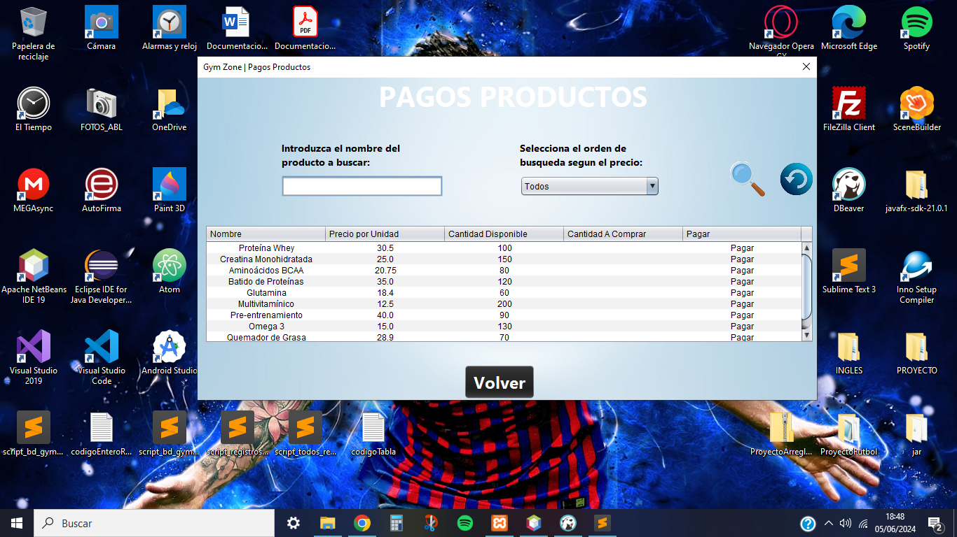

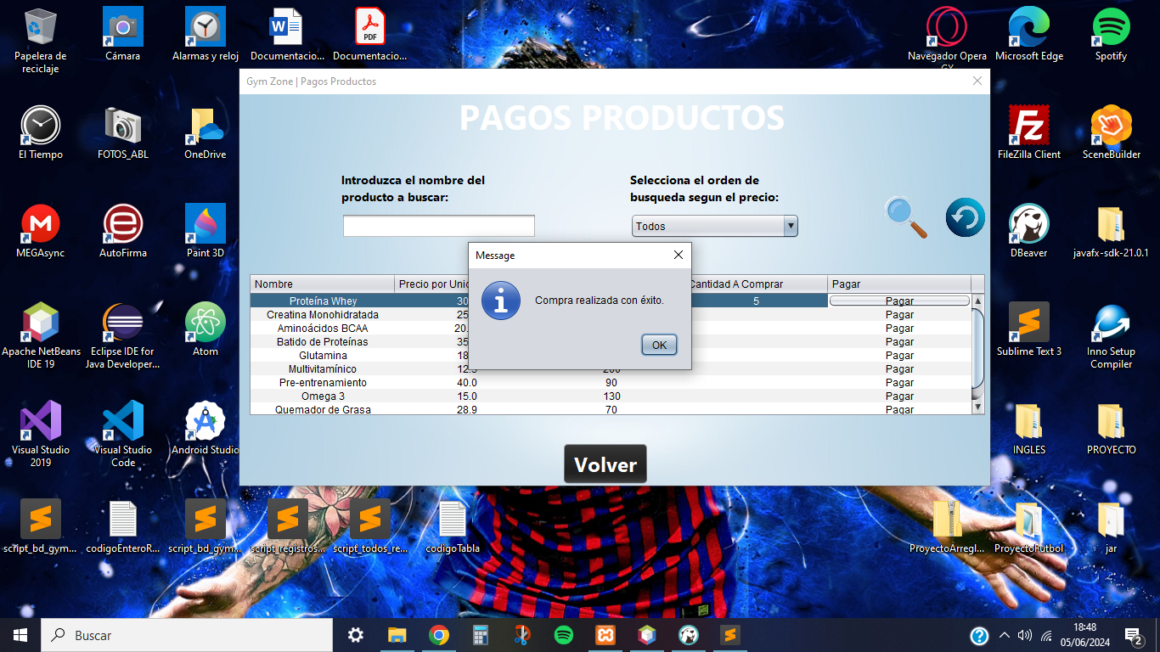

When paying for the product with the desired amount, this amount will be subtracted from the available amount of the purchased product and the cost of the product will be removed from the balance of the registered bank account.

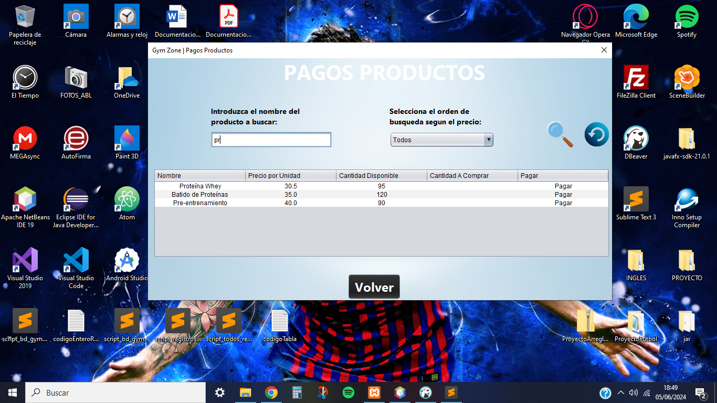

In the section to pay for service, the customer will be able to purchase the desired service, where he can later cancel at any time. In addition, the table can be filtered by name or price (cheaper or more expensive).

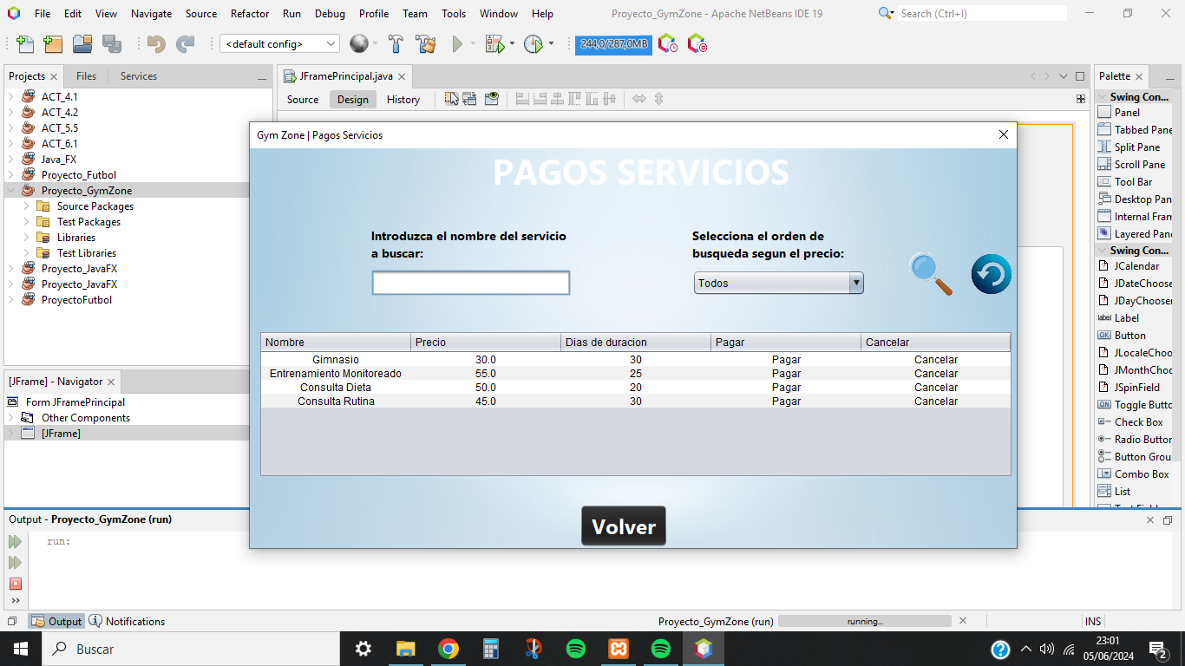

When paying for the service, the price of the service will be subtracted from the balance of the bank account and the expiration date will be recorded, which when the date is reached, the service will go to Canceled status.

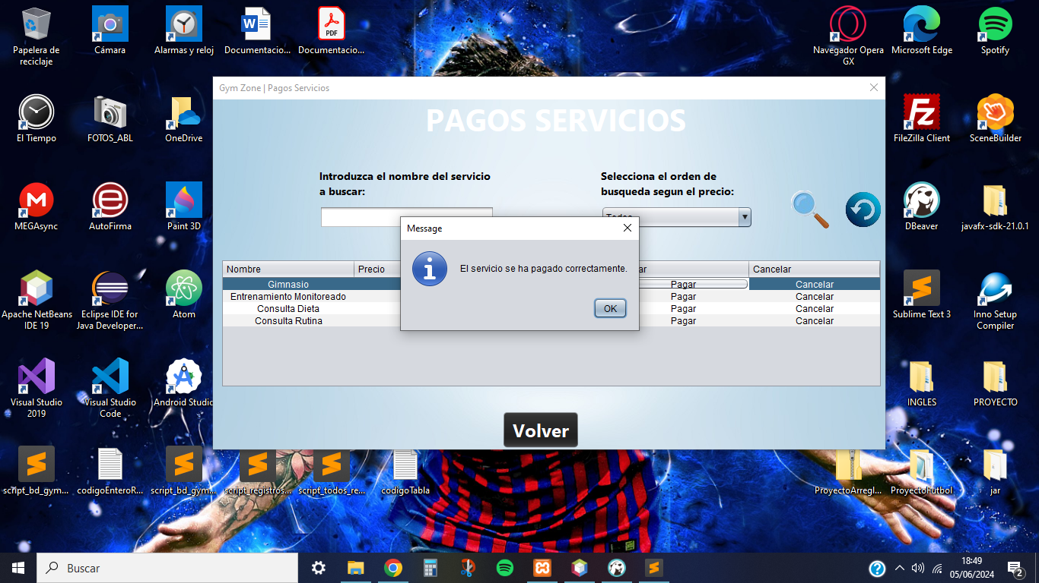

In case you have paid for the Gym service (Room reservations without instructor) and you wish to pay for the Monitored Training service (Room reservations with monitor), the system will prevent it and will notify you as you can only pay for one of them where the customer will choose.

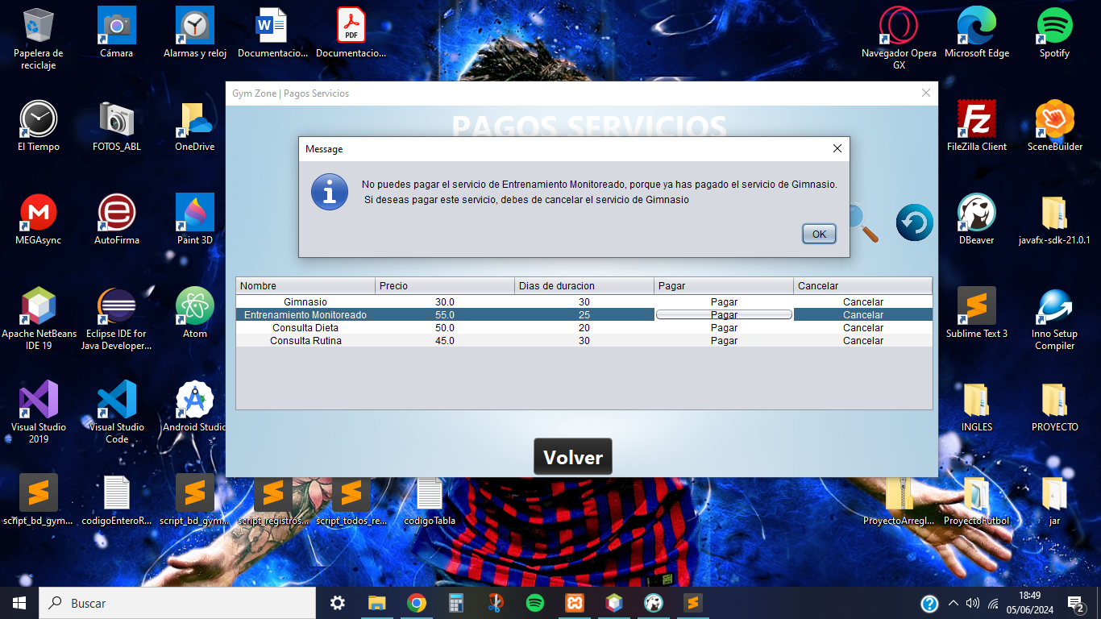

When canceling the service, half of the service fee will be subtracted from the bank account balance and will go to the Canceled status.

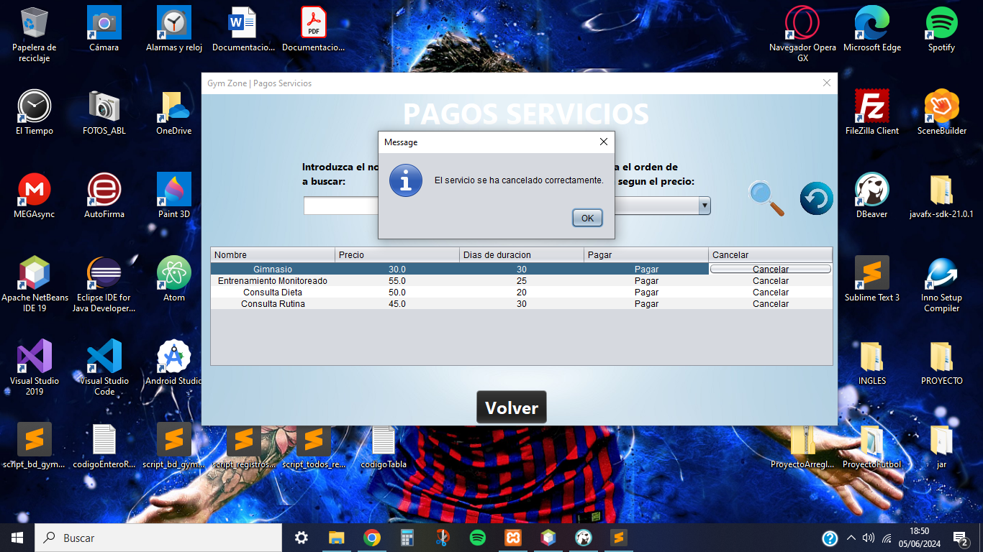

## **Reservation Management**

In this screen, the client will be able to manage the reservations he/she wishes to make, where he will have to pay for the Gym or Monitored Training service to access this functionality.

In the event that the shifts have ended, the client will have to wait until tomorrow to make new reservations and the system will delete the reservations of previous days.

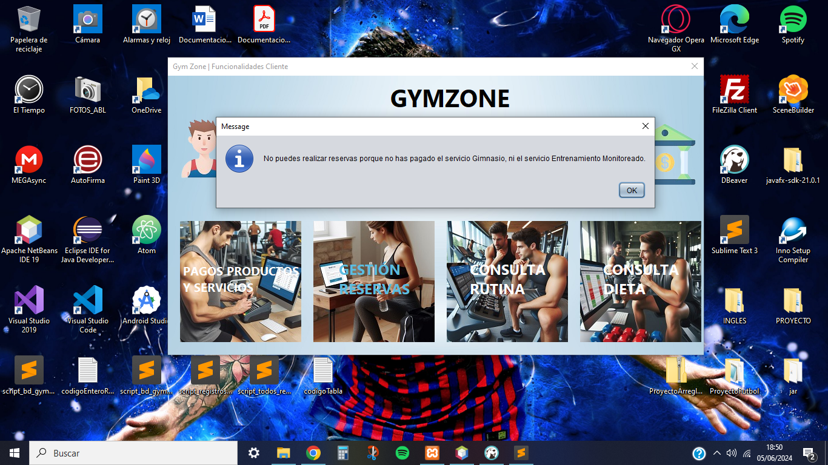

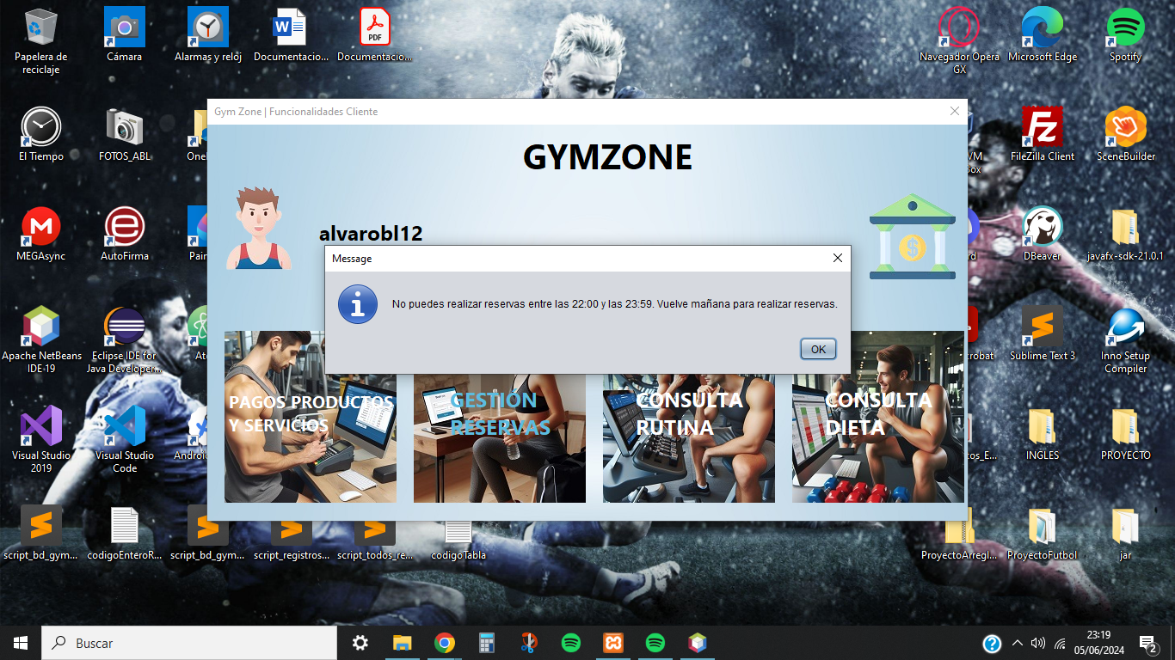

The client will be able to reserve rooms in a certain time slot and later manage them, where previously he has had to make a reservation to be able to manage it.

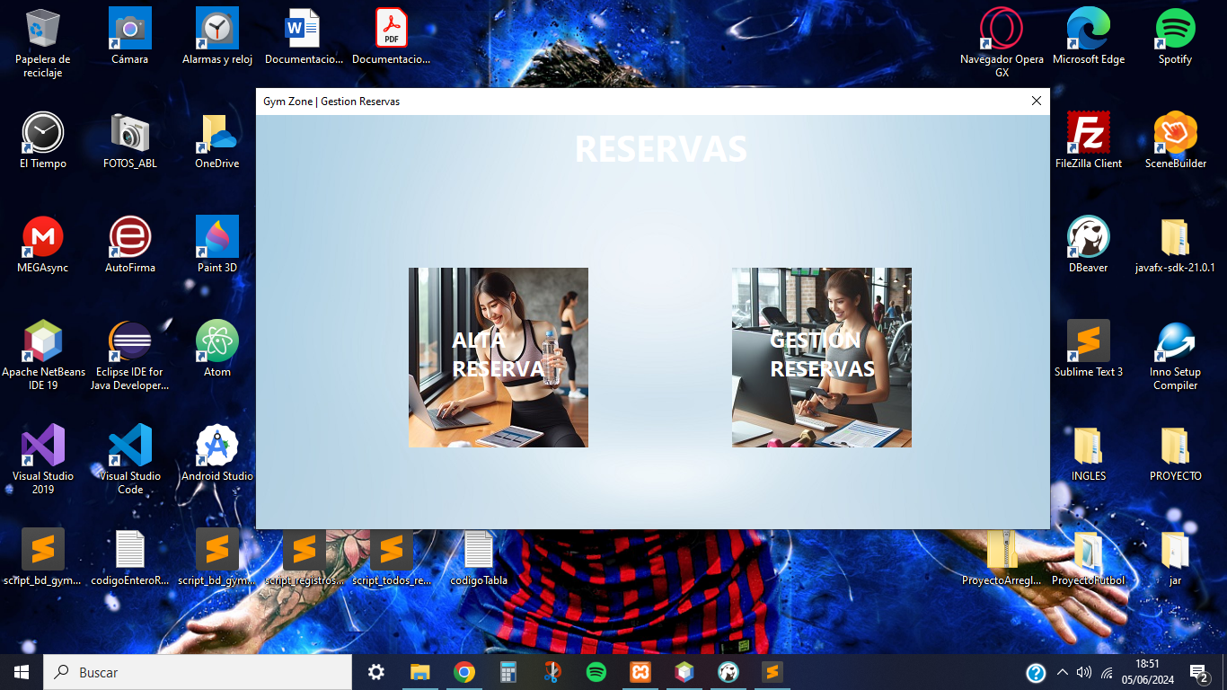

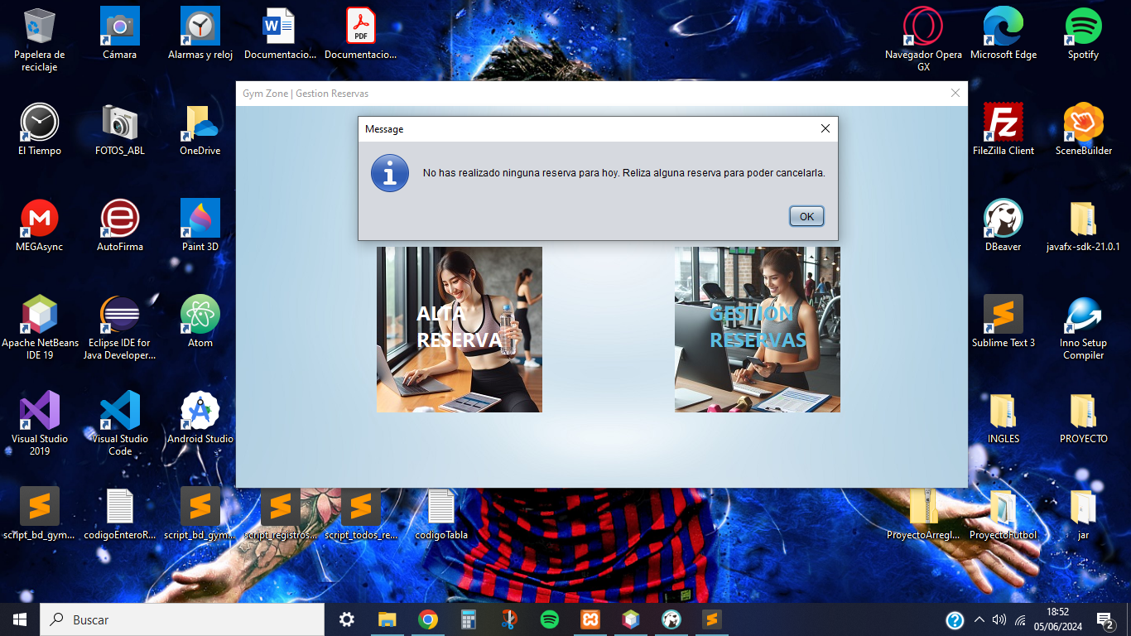

When making a reservation, the client will only be able to make one reservation per shift. There are two shifts with their respective time slots:

* Morning shift: this shift has these time slots:
  + from 8:00 to 10:00.
  + from 10:00 to 12:00.
  + from 12:00 to 14:00.
* Afternoon shift: this shift has these time slots:
  + from 16:00 to 18:00.
  + from 18:00 to 20:00.
  + from 20:00 to 22:00.

In the event that the departure time in the time slot has passed, the client will not be able to make the reservation with that time slot, since the system will delete it after that time has passed. For example, it is 11:00 a.m. and the client cannot book the time slot from 8:00 to 10:00.

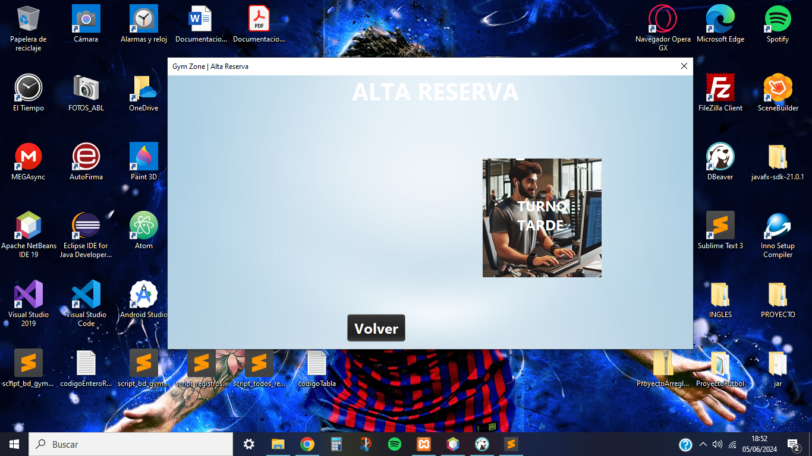

To make the reservation, the client chooses the time slot and the desired and available room, where the system will previously check that the client can perform in that room at that time because if the capacity of the room is full, the client will not be able to book and will be notified to choose another time slot or room.

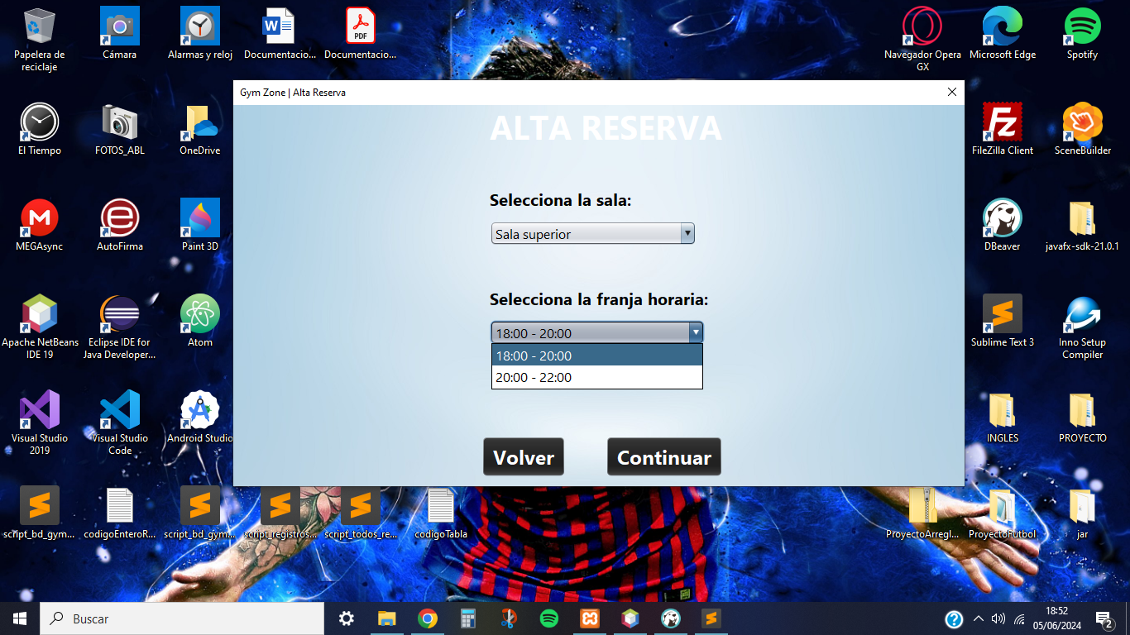

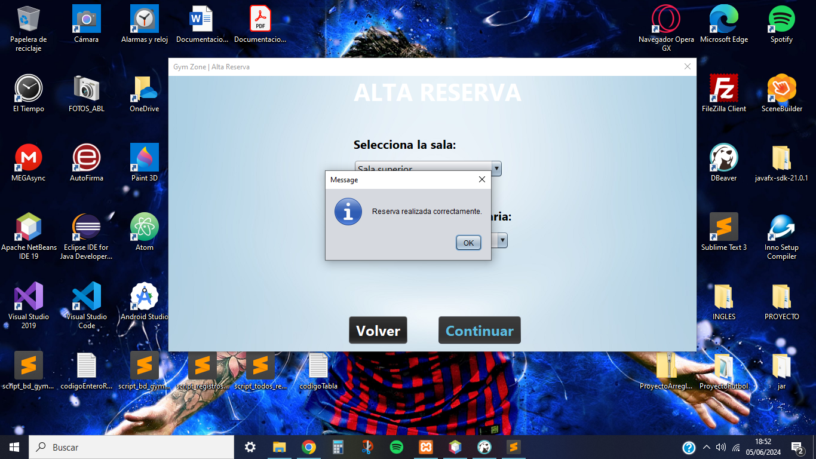

When the client has made a reservation, he/she will be able to go to the reservation management functionality where all the reservations he/she has made will appear regardless of their status (Made or Canceled), where he/she will be able to cancel or rebook the reservation made.

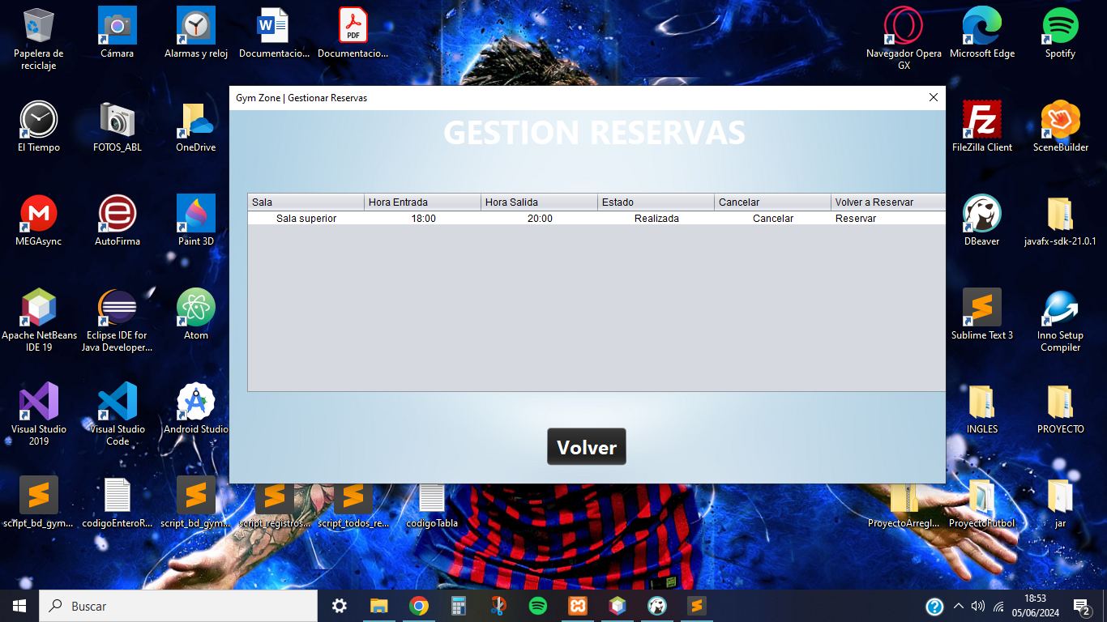

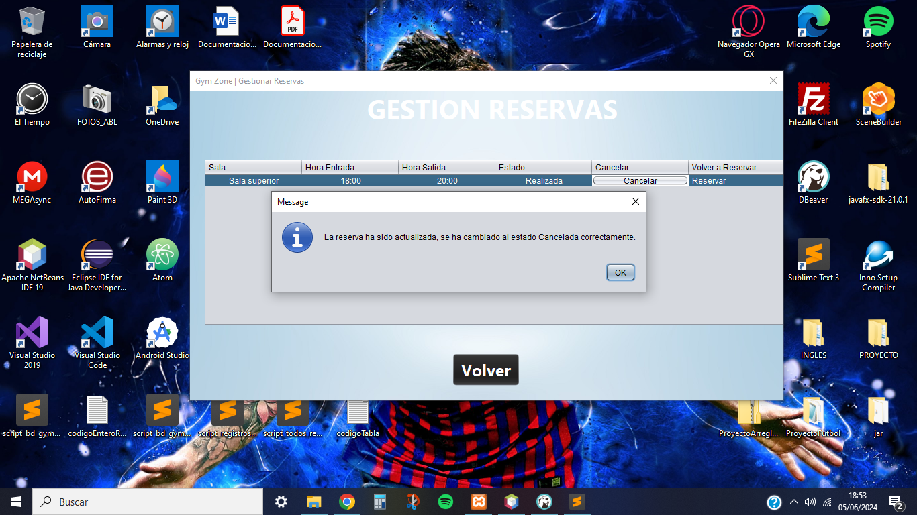

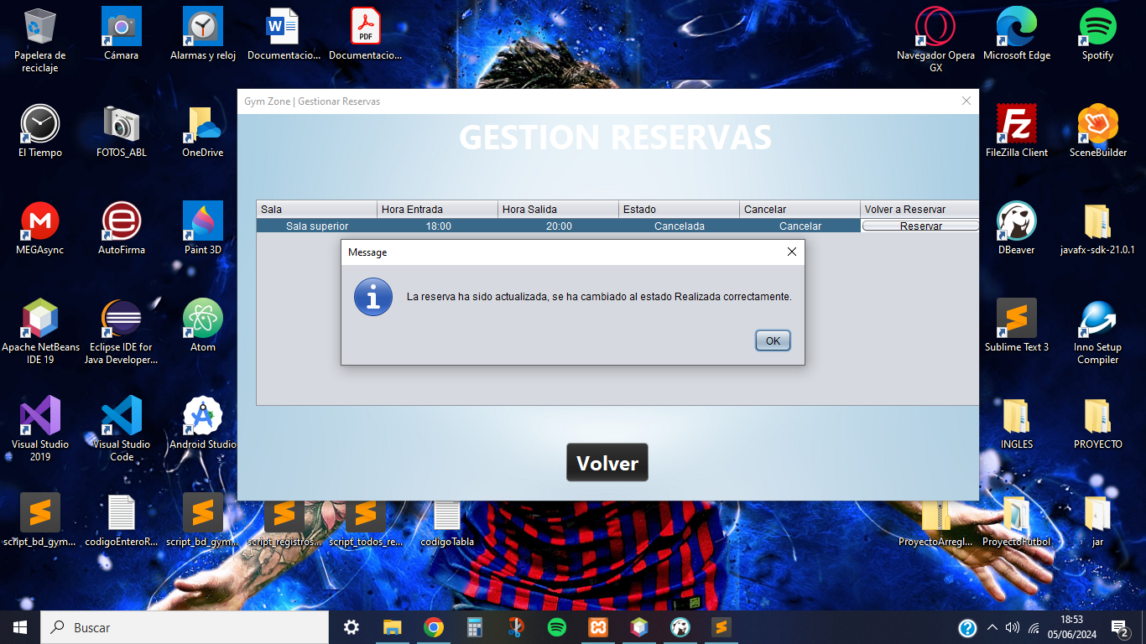

In case, the customer has made a reservation in either the morning or afternoon shift or even missed the departure time of the shift slots, the customer will be notified that he has completed all the reservations that can be made for today.

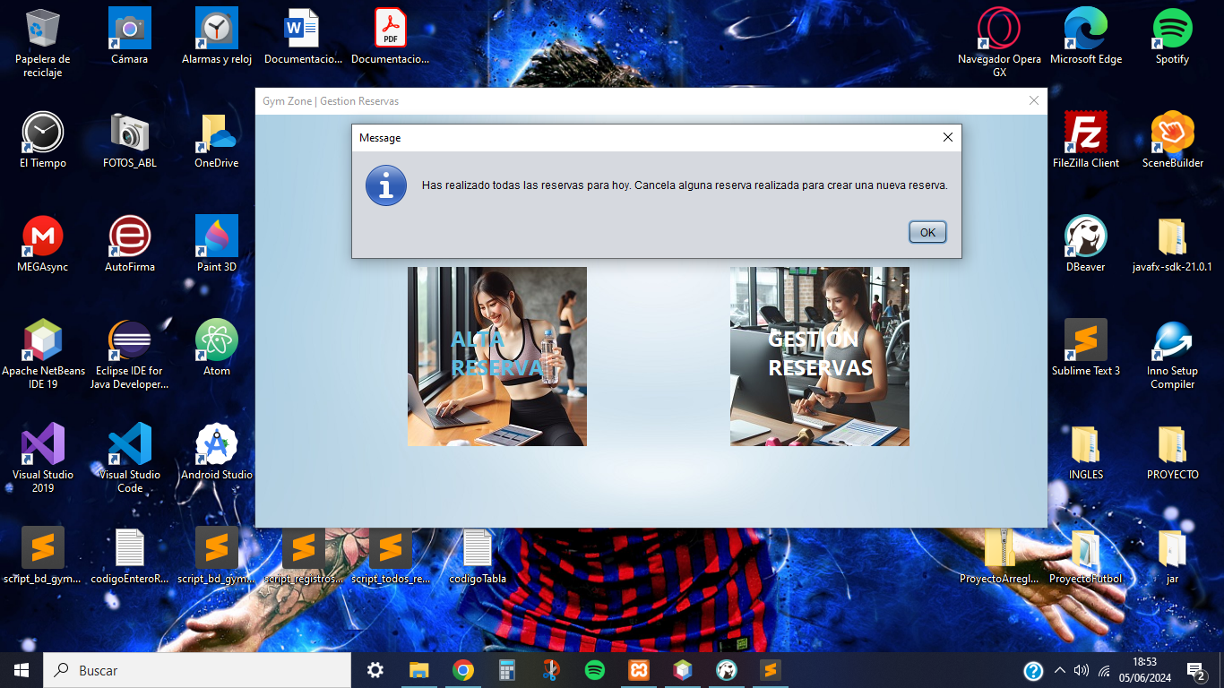

Finally, in case the customer wants to make the same reservation he has made before, the system will prevent him from doing so and will notify him to rebook it in the reservation management functionality.

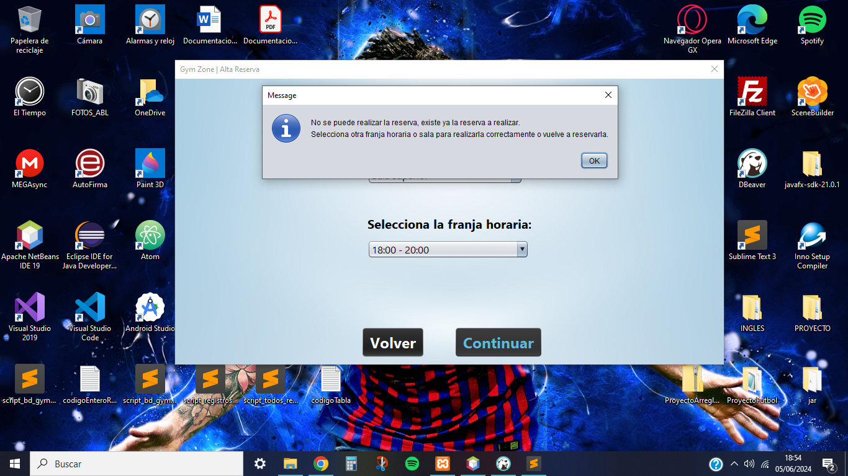

## **Routine Consultation**

In this functionality, the client will be able to visualize the routine corresponding to his body objective created by one of the gym instructors, where he will have to pay for the Routine Consultation service to access it.

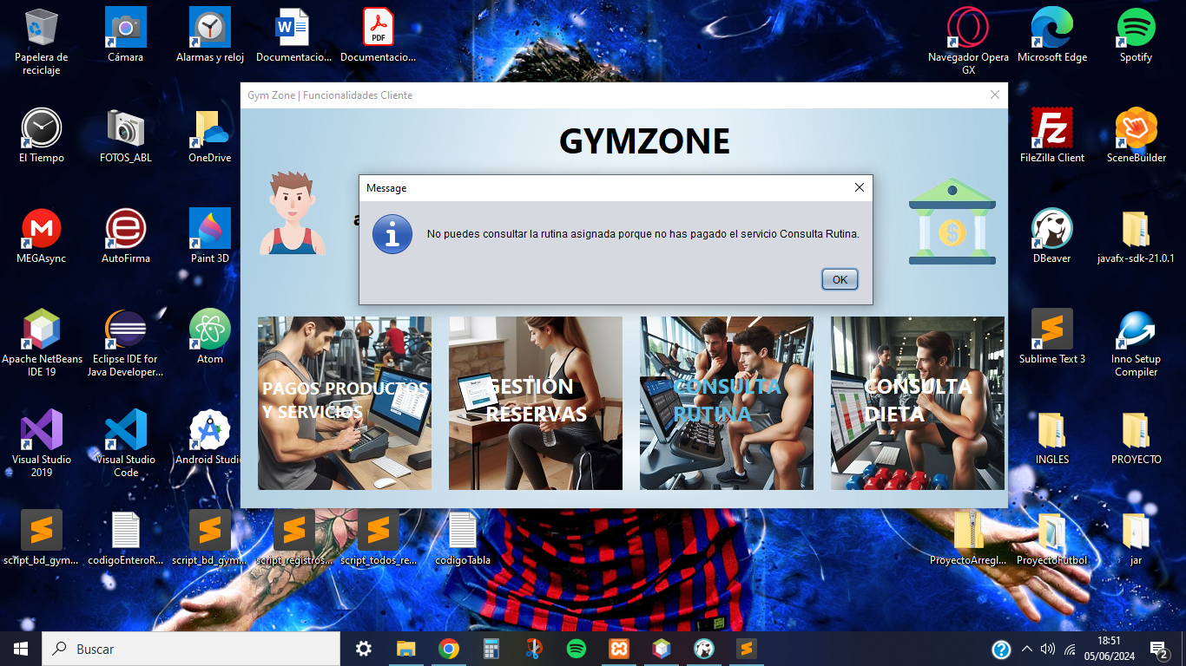

After paying for the service, the client will be able to visualize the provided routine with its respective exercises on each day. This routine can be changed if the client decides to change the body objective.

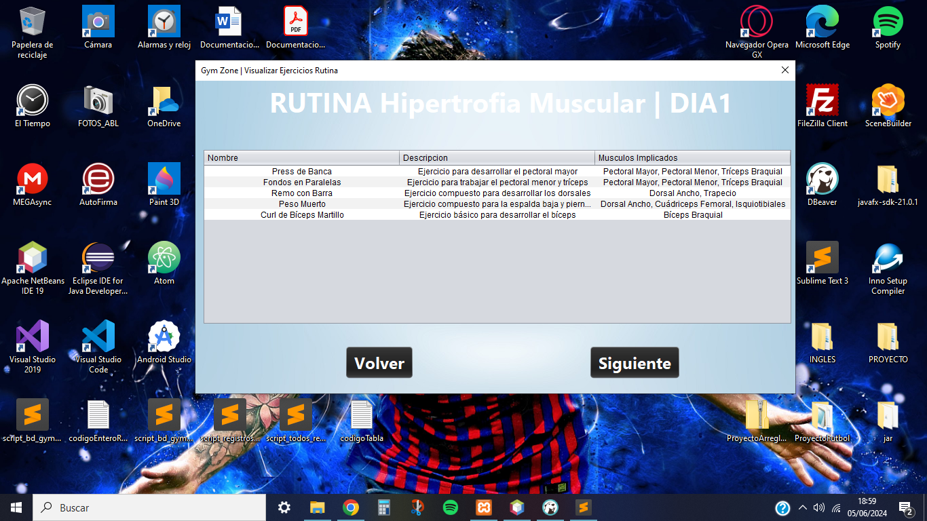

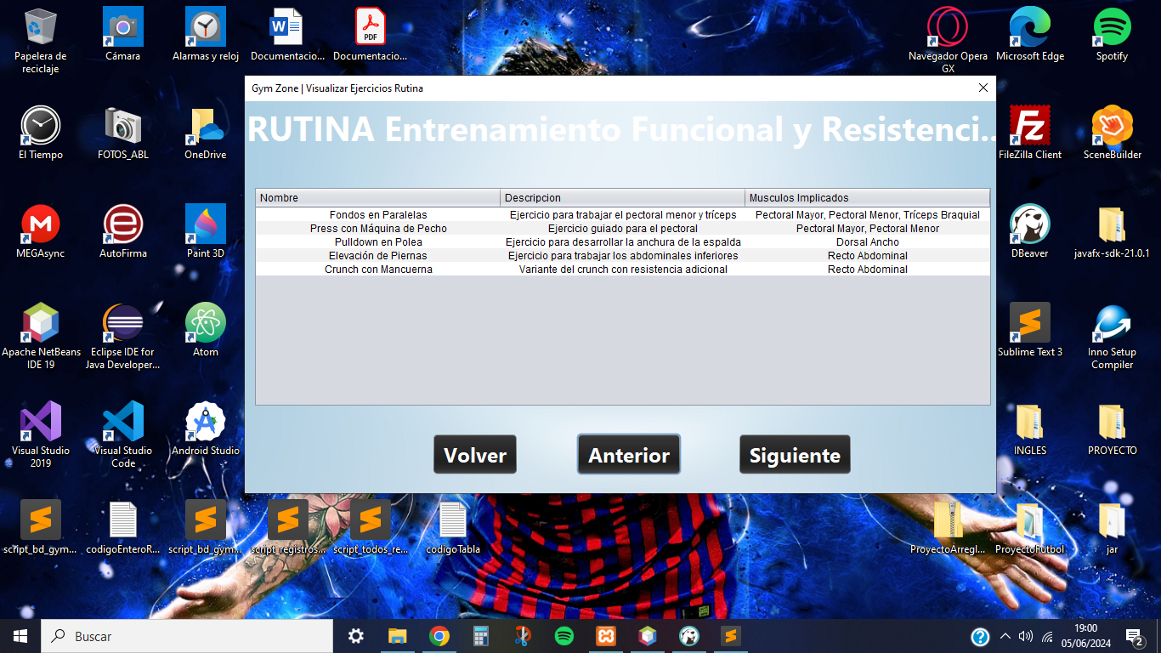

## **Diet Consultation**

In this functionality, the client will be able to visualize the diet corresponding to his body objective created by one of the gym nutritionists, where he will have to pay for the Diet Consultation service to access it.

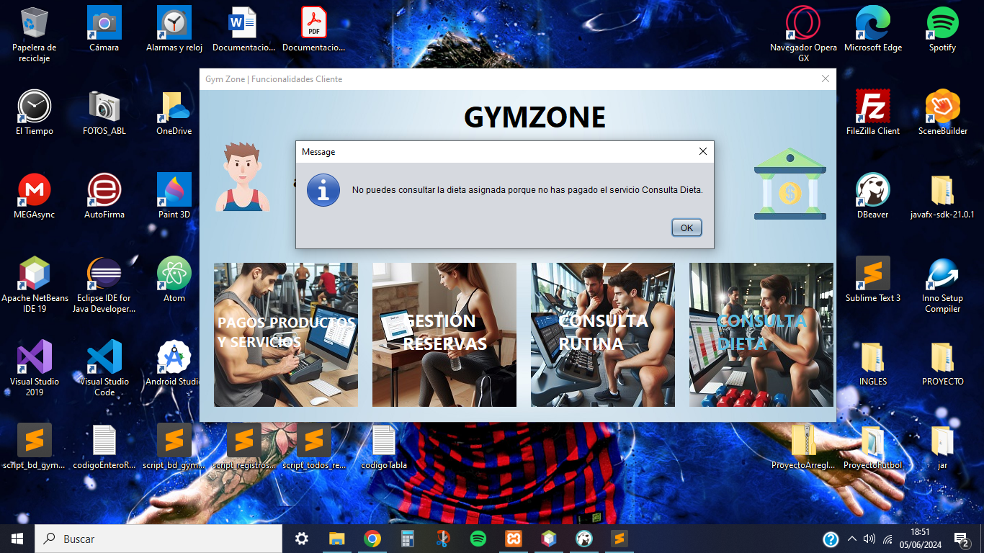

After paying for the service, the client will be able to visualize the diet provided with their respective meals and foods pertaining to each day. This diet can be modified if the client decides to change the body objective.

